Telusko: Core Java 04

031 Encapsulation, Constructor, this vs this() Encapsulation and Constructor
contact details
haider : syedhyder@ineuron.ai
nitin : nitin@ineuron.ai
Given
1. class Dims {
2. public static void main(String[] args) {
3. int[][] a = {{1,2,}, {3,4}};
4. int[] b = (int[]) a[1];
5. Object o1 = a;
6. int[][] a2 = (int[][]) o1;
7. System.out.println(b[1]);
8. }
9. }
What is the result?
A. 2
B. 4
C. An exception is thrown at runtime
D. Compilation fails due to an error on line 4.
E. Compilation fails due to an error on line 5.
F. Compilation fails due to an error on line 6.
Answer: B
Given
1. class Zippy {
2. String[] x;
3. int[] a [] = {{1,2}, {1}};
4. Object c = new long[4];
5. Object[] d = x;
6. }
What is the result?
A. Compilation succeeds.
B. Compilation fails due only to an error on line 3.
C. Compilation fails due only to an error on line 4.
D. Compilation fails due only to an error on line 5.
E. Compilation fails due to errors on lines 3 and 5.
F. Compilation fails due to errors on lines 3, 4, and 5.
Answer: A
Q>
public class Fizz {
int x = 5;
public static void main(String[] args) {
final Fizz f1 = new Fizz();
Fizz f2 = new Fizz();
Fizz f3 = FizzSwitch(f1,f2);
System.out.println((f1 == f3) + " " + (f1.x == f3.x));
}
static Fizz FizzSwitch(Fizz x, Fizz y) {
final Fizz z = x;
z.x = 6;
return z;
}
}
What is the result?
A. true trueB. false true
C. true false
D. false false
E. Compilation fails.
F. An exception is thrown at runtime.
Answer: A
Q>
Given
42. public class ClassA {
43. public int getValue() {
44. int value=0;
45. boolean setting = true;
46. String title=”Hello”;
47. if (value || (setting && title == “Hello”)) { return 1; }
48. if (value == 1 & title.equals(”Hello”)) { return 2; }
49. }
50. }
And:
70. ClassA a = new ClassA();
71. a.getValue();
What is the result?
A. 1
B. 2
C. Compilation fails.
D. The code runs with no output.
E. An exception is thrown at runtime.
Answer: C (operand is not of boolean type is line no 47)
Q>
Given
int a= 8,b=15,c=4;
System.out.println( 2 * ((a%5) * (4+(b-3)/(c+2))));
What is the output?
A. 30
B. 36
C. 32
D. 35
evaluation
2 *((8%5) * (4+(15-3)/(4+2))))
2 * ( (3 * ( 4 + 12/6)))
2 * ( (3 * ( 4 + 2))
2 * ( ( 3 * 6))
2 * (18)
36
answer: B
Q>
What will be the result of compiling and executing DivModTest class?
public class DivModTest {
public static void main(String[] args) {
System.out.println( 23 / 2.0 ); // 11.5
System.out.println( 23 % 2.0 );// 1.0
}}
A. 11
1
B. 11.5
1.0
c. 11.0
1.0
D. 11.5
0.0
Answer: B
Q>
What will be the result of compiling and executing Test class?
public class Test {
public static void main(String[] args) {
System.out.println("Hello" + 1 + 2 + 3 + 4);
}
}
A. Hello10
B. Hello19
C. Hello1234
D. Hello10
Answer: C
Q>
What will be the result of compiling and executing Test class?
public class Test {
public static void main(String[] args) {
System.out.println(1 + 2 + 3 + 4 + "Hello");
}
}
A. 1234Hello
B. 10Hello
C. 64Hello
D. 10 Hello
Answer: B(10Hello)
Q> What will be the result of compiling and executing Test class?
public class Test {
public static void main(String[] args) {
System.out.println("Output is: " + 10 != 5);
}
}
A. Output is : true
B. Output is : false
C. Compilation error
D. Output is : 10 !=5
Answer: C(On String Objects only + operator is allowed other operators would result
in CompileTimeError)
Q>
What will be the result of compiling and executing Test class?
public class Test {
public static void main(String[] args) {
System.out.println("Output is: " + (10 != 5));}
}
A. Output is : true
B. Output is : false
C. Compilation error
D. Output is : 10 !=5
Answer: A
Q>
What will be the result of compiling and executing the Test class?
public class Test {
public static void main(String[] args) {
int grade = 75;
if(grade > 60)
System.out.println("Congratulations");
System.out.println("You passed");
else
System.out.println("You failed");
}
}
A. Congratulations
B. Congratulations
You passed
C. You failed
D. compilation error
Answer: D
Q>
What will be the result of compiling and executing the Test class?
public class Test {
public static void main(String[] args) {
int grade = 60;
if(grade = 60)
System.out.println("You passed...");
else
System.out.println("You failed...");
}
}
A. You passed...
B. You failed...
C. compilation error
D. Produces not output
Answer: C
Q>
Predict the following output for the given code
public class TestApp{
public static void main(String... args){
String[] arr[] ={{"%","***"},{"!!!!","@@@@@","######"}};
for(String str[] : arr){
for(String s:str){
System.out.println(s);
if(s.length()==4)
break;
}break;
}
}
}
A. Compile Time Error
B. StringIndexOutOfBoundsException
C. %
***
D. %
***
######
E. ArrayIndexOutOfBoundsException
E. None of the above
Answer: C
Q>
What will be the result of compiling and executing Test class?
public class Test {
public static void main(String[] args) {
int score = 60;
switch (score) {
default:
System.out.println("Not a valid score");
case score < 70:
System.out.println("Failed");
break;
case score >= 70:
System.out.println("Passed");
break;
}
}
}
A. Compilation Error
B. Failed
C. Not a valid score
Failed
D. Passed
Answer: A
Q>
What will be the result of compiling and executing Test class?
public class Test {
public static void main(String[] args) {
String fruit = "mango";
switch (fruit) {
case "Apple":
System.out.println("APPLE");
case "Mango":
System.out.println("MANGO");
case "Banana":
System.out.println("BANANA");
break;
default:
System.out.println("ANY FRUIT WILL DO");
}}
}
A. MANGO
B. ANY FRUIT WILL DO
C. MANGO
BANNANA
D. MANGO
ANY FRUIT WILL DO
E. MANGO
BANNANA
ANY FRUIT WILL DO
Answer: B
What will be the result of compiling and executing Test class?
public class Test {
public static void main(String[] args) {
String fruit = "mango";
switch (fruit) {
default:
System.out.println("ANY FRUIT WILL DO");
case "Apple":
System.out.println("APPLE");
case "Mango":
System.out.println("MANGO");
case "Banana":
System.out.println("BANANA");
break;
}
}
}
A. ANY FRUIT WILL DO
B. MANGO
C. MANGO
BANNANA
D. ANY FRUIT WILL DO
APPLE
MANGO
BANNANA
Answer: D

class DBConnectivity
{
public DBConnectivity()
{
System.out.println("Connect to database");
}
}

public class LaunchDB {

public static void main(String[] args) {
// TODO Auto-generated method stub

DBConnectivity db=new DBConnectivity();

}

}

class Dog
{
private String name;
private int cost;

public String getName() {
return name;
}
public void setName(String name) {
this.name = name;
}
public int getCost() {
return cost;
}
public void setCost(int cost) {
this.cost = cost;
}
}
public class LaunchDog {

public static void main(String[] args) {
Dog d=new Dog();
d.setName("Sheru");
System.out.println(d.getName());
d.setCost(2000);
int cost=d.getCost();
System.out.println(cost);
}

}
class Student
{
private int age; //instance variable//Data Member//Fields
private String name; //properties
private String city;
private boolean married;

public int getAge() {
return age;
}
public void setAge(int age) {
this.age = age;
}
public String getName() {
return name;
}
public void setName(String name) {
this.name = name;
}
public String getCity() {
return city;
}
public void setCity(String city) {
this.city = city;
}
public boolean isMarried()
{
return married;
}
}
public class LaunchEncap {

public static void main(String[] args) {

Student st=new Student();
st.setCity("Pune");
System.out.println(st.getCity());

Student st2=new Student();
st2.setCity("Bengaluru");
System.out.println(st.getCity());

}

}

class Student1
{
private String name;
private int age;
private String city;

public Student1(String name, int age, String city)
{
this.name=name;
this.age=age;
this.city=city;

}
public String getName() {
return name;
}
public int getAge() {
return age;
}
public String getCity() {
return city;
}
}
public class LaunchStd {
public static void main(String[] args) {
Student1 std1=new Student1("Rohit", 17,"Hyderabad");
//std1.setData("Rohan", 18, "Bengaluru");

System.out.println(std1.getName());
System.out.println(std1.getAge());
System.out.println(std1.getCity());

}

}
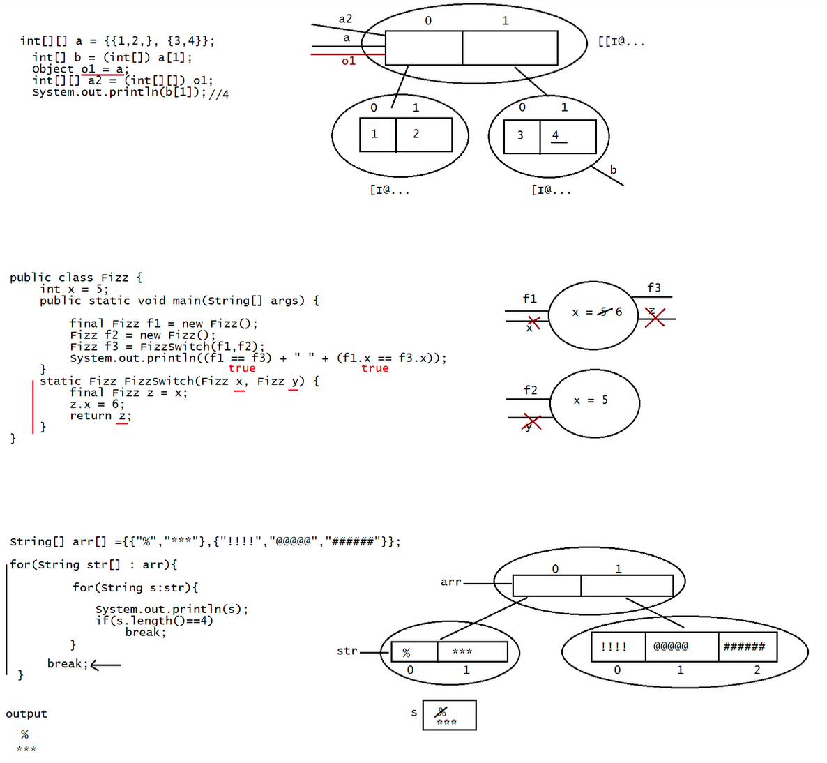
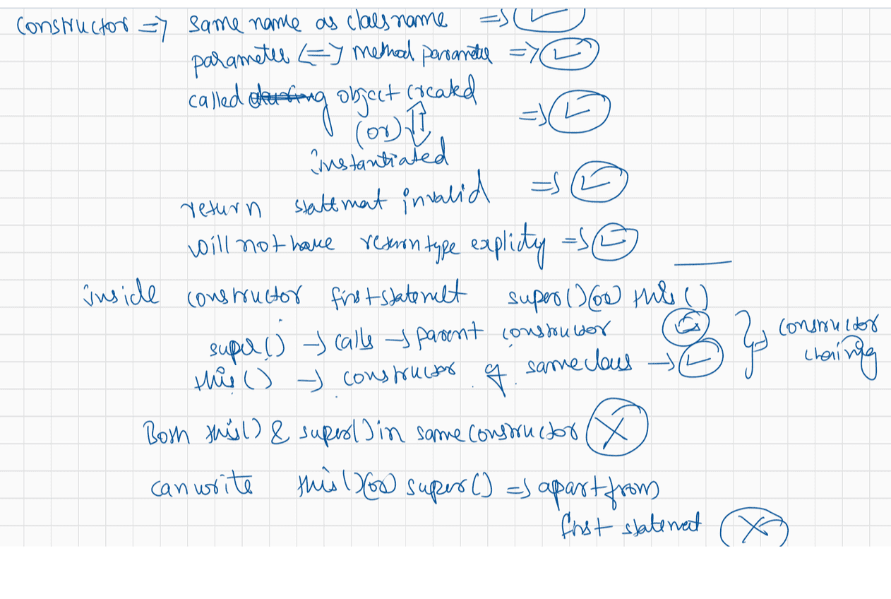
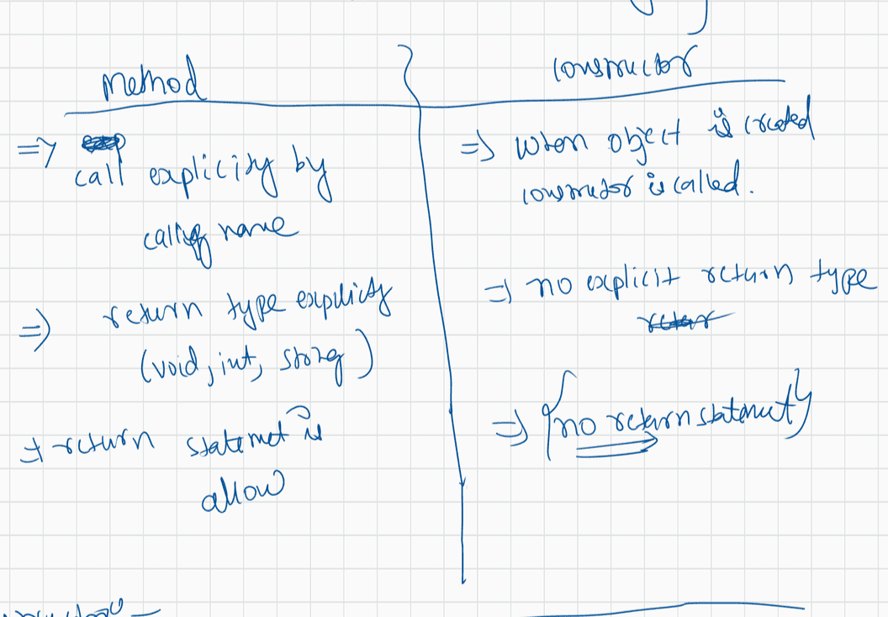
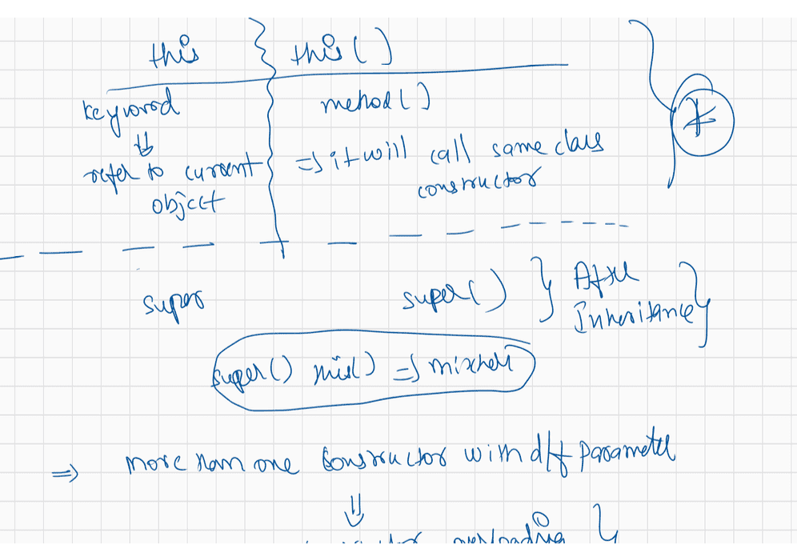

032 Static keyword in Java
contact details
hyder: syedhyder@ineuron.ai
nitin : nitin@ineuron.ai
What will be the result of compiling and executing Test class?
public class Test {
public static void main(String[] args) {
byte var = 100;
switch(var) {
case 100:
System.out.println("var is 100");
break;
case 200:
System.out.println("var is 200");
break;
default:
System.out.println("In default");
}
}
}
A. var is 100
B. var is 200
C. In default
D. CompileTime error.
Answer: D
What will be the result of compiling and executing Test class?
public class Test {
public static void main(String[] args) {
String fruit = new String(new char[] {'M', 'a', 'n', 'g', 'o'});
switch (fruit) {
default:
System.out.println("ANY FRUIT WILL DO");
case "Apple":
System.out.println("APPLE");
case "Mango":
System.out.println("MANGO");
case "Banana":
System.out.println("BANANA");
break;
}
}
}
A. ANY FRUIT WILL DO
B. MANGO
C. MANGO
BANANA
D. ANY FRUIT WILL DO
APPLE
MANGO
BANANA
Answer: C
Q>
Consider below code://Test.java
public class Test {
public static void main(String [] args) {
boolean flag = !true;//false
System.out.println(!flag ? args[0] : args[1]);
}
}
What will be the result of compiling and executing Test class using below commands?
javac Test.java
java Test AM PM
A. AM
B. PM
C. ExceptionInitalizerError while loading the .class file
D. CompilationError
args[0] = "AM"
args[1] = "PM"
System.out.println(true? "AM":"PM");
Answer: A
What will be the result of compiling and executing Test class?
public class Test {
public static void main(String [] args) {
int a = 3;// a = 4
System.out.println(a++ == 3 || --a == 3 && --a == 3);//true
System.out.println(a);//4
}
}
A. true
3
B. false
3
C. True
3
D. False
3
E. true
4
F. false
3
G. CompilationError
Answer: E
Q>
What will be the result of compiling and executing Test class?
public class Test {
public static void main(String [] args) {
int a = 3;
m(++a, a++);
System.out.println(a);
}
private static void m(int i, int j) {
i++;
j--;
}
}A. 4
B. 5
C. 6
D. 3
Answer: B
Q>
Consider below code of Test.java file:
public class Test {
public static void main(String [] args) {
boolean flag = false;//true, false
System.out.println((flag = true) | (flag = false) || (flag = true));//
true |false => true || (flag=true)
System.out.println(flag);//false
}
}
A. true
false
B. false
true
C. true
true
D. false
false
E. CompilationError
What is the result of compiling and executing Test class?
Answer: A
Q>
Consider below code of Test.java file:
public class Test {
public static void main(String [] args) {
boolean status = true;
System.out.println(status = false || status = true | status = false);
System.out.println(status);
}
}
A. true
false
B. false
true
C. true
true
D. false
false
E. CompilationError
What is the result of compiling and executing Test class?
Answer: E
Q>
What will be the result of compiling and executing Test class?
public class Test {
public static void main(String[] args) {
String msg = "Hello";
boolean [] flag = new boolean[1];if(flag[0]) {
msg = "Welcome";
}
System.out.println(msg);
}
}
A. Hello
B. Welcome
C. ArrayIndexOutOfBoundsException
D. NullPointerException
E. CompileTimeError
Answer: A
public class Test {
public static void main(String [] args) {
boolean flag1 = true;
boolean flag2 = false;
boolean flag3 = true;
boolean flag4 = false;
System.out.println(!flag1 == flag2 != flag3 == !flag4); //Line n1
System.out.println(flag1 = flag2 != flag3 == !flag4); //Line n2
}
}
What will be the result of compiling and executing Test class?
A. Line n1 cause compilation error
B. Line n2 causes compilatione error
C. true
true
D. true
false
E. false
true
F. false
false
JVM
===
!true == false != true == !false
false== false != true == !false
true != true == !false
false == true
false
flag1 = false!= true == !false
flag1 = true == true
flag1 = true
true
Answer: E
Q>
public class Test {
public static void main(String[] args) {
int score = 30; // Line n1
char grade = 'F'; // Line n2
if (50 <= score < 60) // Line n3
grade = 'D';else if (60 <= score < 70) // Line n4
grade = 'C';
else if (70 <= score < 80) // Line n5
grade = 'B';
else if (score >= 80)
grade = 'A';
System.out.println(grade);
}
}
A. Compilation error
B. A
C. B
D. C
D. F
System.out.println(10<20<30);//CE:nesting or relational operator is not possible
Answer: A
Q>
Consider below code of Test.java file:
public class Test {
public static void main(String[] args) {
int x = 10; //Line n1
if (false)
System.out.println(x); //Line n2
System.out.println("HELLO"); //Line n3
}
}
What is the result of compiling and executing Test class?
A. Compilation error at Line n1
B. Compilation error at Line n2
C. Compilation error at Line n3
D. HELLO
E. 10
HELLO
Answer: D(unreachable won't be checked by compiler for if and else logic)

class Demo1
{
int a;
int b;

static int count;

{
count++;
System.out.println("Hello");
}

Demo1()
{
this(100);
System.out.println("First con");
}
Demo1(int a)
{
System.out.println(a);
this.a=a;

}
Demo1(int a, int b)
{
this.a=a;
this.b=b;
}
}

public class LaunchNonStaticBlock {

public static void main(String[] args) {
Demo1 d1=new Demo1();
Demo1 d2=new Demo1(10,20);
Demo1 d3=new Demo1(10);

System.out.println(Demo1.count);

}

}
class Demo
{
static int a;
static int b;

static
{
System.out.println("Static block");
a=10;
b=20;

}
static void disp()
{
System.out.println("Static method");
System.out.println(a);
System.out.println(b);
}
int x;
int y;

{
x=10;
y=20;
System.out.println("Non static Java blick");
}
Demo()
{

System.out.println("Constructor");
}
void disp1()
{
System.out.println("Non static method");
System.out.println(x);
System.out.println(y);

}
void disp2()
{
disp1();
}
}

public class LaunchStatic
{

public static void main(String[] args) {

Demo.disp();
Demo d=new Demo();
d.disp();
d.disp1();

}

}

public class LaunchStaticBlock {

static int a;

static {
a=10;
System.out.println("Static block1");
}
public static void main(String[] args) {
// TODO Auto-generated method stub
System.out.println("Main method");

}

}

public class LaunchStaticControlFlow {
static int a;
static int b;

static
{
System.out.println("Static block");
a=10;
b=20;
}
static void disp()
{
System.out.println("Static disp method");
System.out.println(a);
System.out.println(b);
}

public static void main(String[] args) {
// TODO Auto-generated method stub
System.out.println("Main method");
disp();
}

}

class Demo2
{
static int a;

static
{
a=10;
}

static void disp()
{
System.out.println("Static disp "+ a);
}
}

public class LaunchStaticMethods {

static void disp2()
{
System.out.println("Disp 2");
}
public static void main(String[] args) {

System.out.println("main method");
disp2();
Demo2.disp();

Demo2 d=new Demo2();
d.disp();

}

}
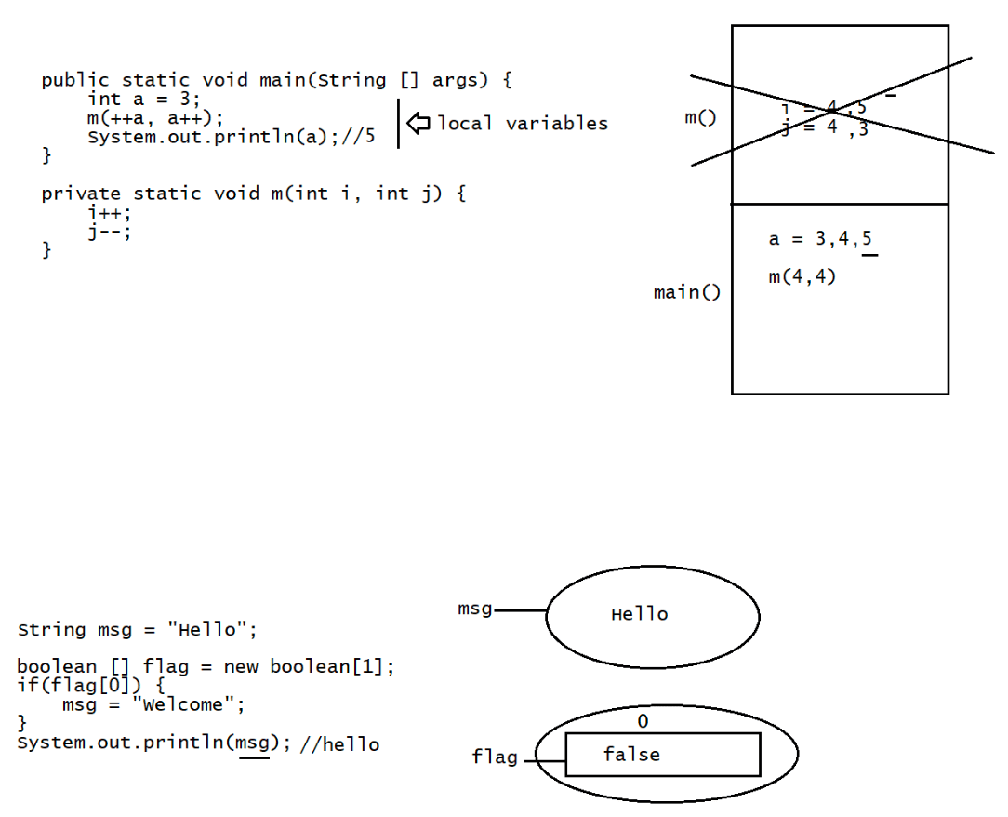
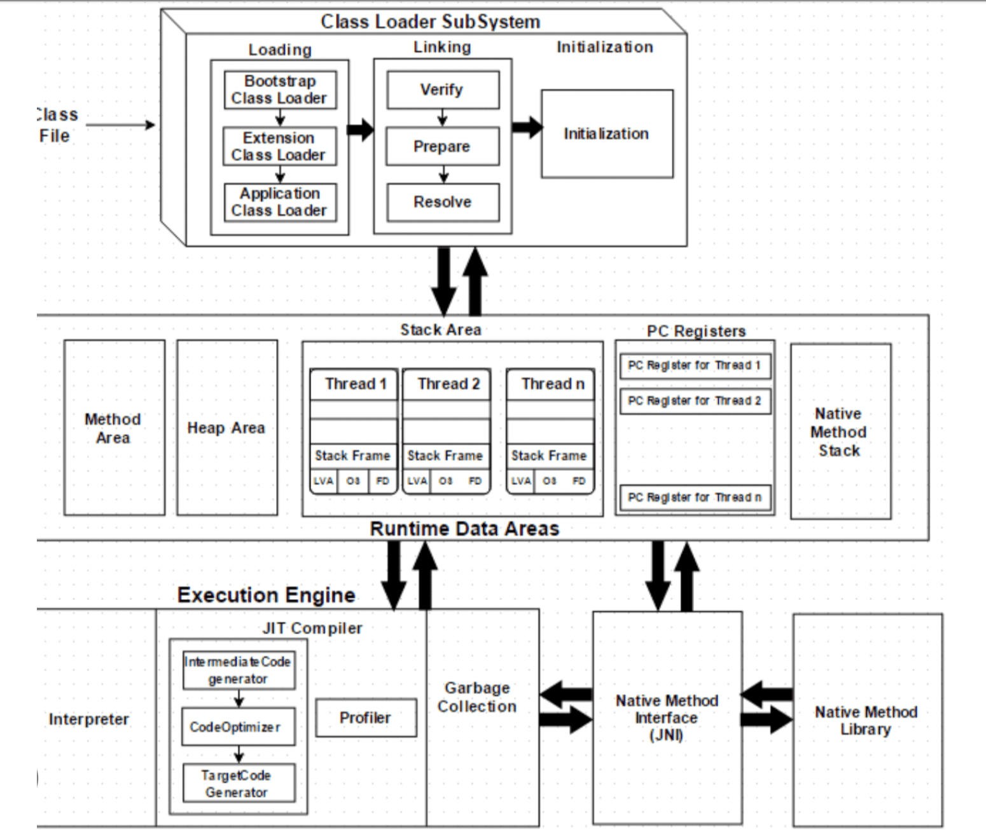
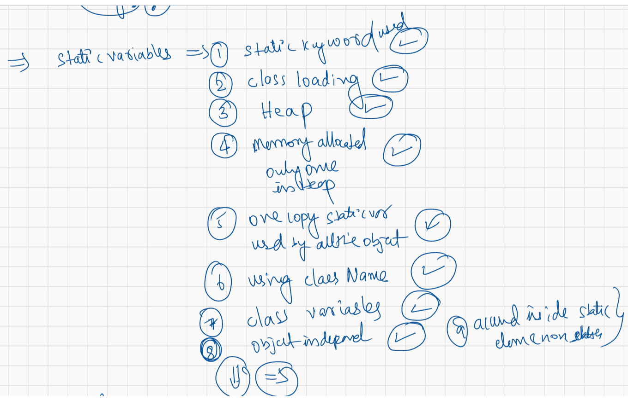
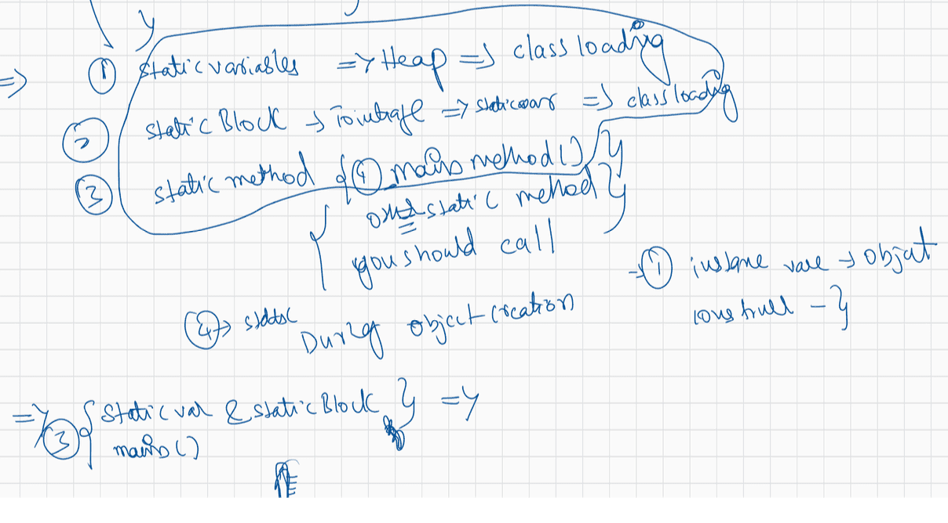
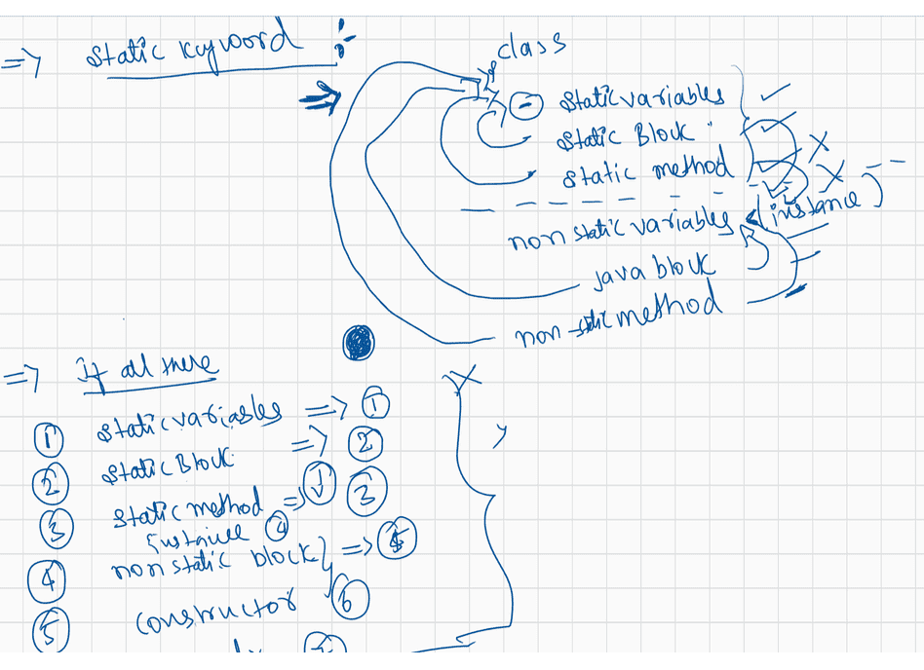

033 Static and Inheritance in Java
Consider below code of Counter.java file:
public class Counter {
int count;
private static void increment(Counter counter) {
counter.count++;
}
public static void main(String [] args) {
Counter c1 = new Counter();
Counter c2 = c1;
Counter c3 = null;
c2.count = 1000;
increment(c2);
}
}
A. 1
B. 2
C. 3
D. 4
On executing Counter class, how many Counter objects are created in the memory?
Answer: A
Q>
Consider below code of Test.java file:
public class Test {
public static void main(String[] args) {
String res = "";
loop: for(int i = 1; i <= 5; i++) { //Line n1
switch(i) {
case 1:
res += "UP ";
break;
case 2:
res += "TO ";
break;
case 3:
break;
case 4:
res += "DATE";
break loop;
}
}
System.out.println(res);//UP TO DATE
System.out.println(String.join("-", res.split(" "))); //Line n2
What will be the result of compiling and executing Test class?
}
}
i = 1
res = UP
i = 2
res = UP TO
i=3
res = UP TO
i=4
res = UP TO DATESystem.out.println(String.join("-",["UP","TO","DATE"]))//take the input from an
array and join with delimiter specified
System.out.println("UP-TO-DATE") //UP-TO-DATE
Q>
Consider below code of Test.java file:
public class Test {
public static void main(String[] args) {
String res = ""; //Line n1
String [] arr = {"Dog", null, "Friendly"};
for(String s : arr) { //Line n2
res += String.join("-", s); //Line n3
}
System.out.println(res); //Line n4
}
}
What will be the result of compiling and executing Test class?
A. DogFriendly
B. Dog-Friendly
C. DognullFriendly
D. Dog-null-Friendly
E. NullPointerException is thrown
F. CompileTimeError
res = ""
arr = {"Dog", null, "Friendly"}
s = Dog
res = "" + String.join("-","Dog")
="" + Dog
= "Dog"
s = null
res = "Dog"+ String.join("-",null)
= "Dognull"
s = Friendly
res = "Dognull" + String.join("-","Friendly")
= "Dognull"+"Friendly"
res = "DognullFriendly"
Output: C
Q>
Given code
public static void main(String[] args) {
String[][] chs = new String[2][];
chs[0] = new String[2];chs[1] = new String[5];int i=97;
for (int a=0; a<chs.length;a++ ){
for (int b=0;b<chs.length;b++ ){
chs[a][b] = " "+i;
i++;
}
}
for (String[] ca:chs ){
for (String c: ca ){
System.out.print(c + " ");
}
System.out.println();}
}
A. 97 98
99 100 null null null
B. 97 98
99 100 101 102 103
C. Compilation fails.
D. NullPointer exception is thrown at runtime.
E. ArrayIndexOutOfBoundsException is thrown at runtime.
Answer: A
Q>
public static void main(String... args) {
String ta="A ";
ta = ta.concat("B ");
String tb="C ";
ta = ta.concat(tb);
ta.replace('C', 'D');
ta=ta.concat(tb);
System.out.println(ta);
}
A. A B C D
B. A C D
C. A B C C
D. A B D
E. A B D C
F. CompileTimeError
G. Some Problem at the runtime by JVM.
ta = "A B C C "
tb = "C "
Answer: C
Q>
Consider below code of Test.java file:
public class Test {
public static void main(String[] args) {
StringBuilder sb = new StringBuilder("B"); //Line n1
sb.append(sb.append("A")); //Line n2
System.out.println(sb); //Line n3
}
}
A. B
B. BA
C. AB
D. BAB
E. ABA
F. ABAB
G. BABA
H. ABBA
I. CompilationError at line 2
sb = "BA"
"BA". append("BA");
sb = "BABA"
What will be the result of compiling and executing Test class?Q>
public class Test {
public static void main(String[] args) {
String [] arr = {"1st", "2nd", "3rd", "4th", "5th"};
String place = "faraway";
System.out.println(arr[place.indexOf("a", 3)]); //Line n1
}
}
What will be the result of compiling and executing Test class?
A. 1st
B. 3rd
C. 4th
D. 5th
E. 2nd
F. RunTimeException
G. Compiletime Error at line n-1
arr[0] = 1st
arr[1]= 2nd
arr[2] = 3rd
arr[3] = 4th
arr[4] = 5th
place = "faraway"
System.out.println( arr[3]);
Answer: C

class Parentt
{
int a, b;

Parentt()
{

a=10;
b=20;
System.out.println("Parentt Const");
}
Parentt(int a, int b)
{
this.a=a;
this.b=b;
System.out.println("Parentt para Const");
}

}

class Childd extends Parentt
{

int x, y;

Childd()
{
this(111,222);
x=100;
y=200;
}
Childd(int x, int y)
{

this.x=x;
this.y=y;
}
void disp()
{
System.out.println(a);
System.out.println(b);
System.out.println(x);
System.out.println(y);

}
}
public class LaunchConst {

public static void main(String[] args) {
// TODO Auto-generated method stub
Childd ch=new Childd();
ch.disp();
Childd ch1=new Childd(1000,2000);
ch1.disp();

}

}

//class Demo123 extends Demo321
//{

//}
//class Demo321 extends Demo123
//{

//}

class Parent11
{
private String name;

Parent11()
{
System.out.println("Parent Constructor");
}
void disp()
{
System.out.println("Parent ");
}
}
class Child11 extends Parent11
{
//Child11()
//{
//super();
//}
void disp2()
{
//name="Hyder"; private memebrs will not participate in inheirtamce
}
}
public class LaunchCyclic {

public static void main(String[] args) {
Child11 c=new Child11();
c.disp();

}

}
import java.util.Scanner;

class Farmer
{
private float pa;
private float td;
private float si;
private static float ri; //class variables

static
{
ri=2.5f;
}

public void acceptInput()
{
Scanner scan=new Scanner(System.in);
System.out.println("Dear, Kindly enter loan amount needed");
pa=scan.nextFloat();
System.out.println("Dear, Kindly enter time needed to repay");
td=scan.nextFloat();

}

public void compute()
{
si=(pa*td*ri)/100;
}

public void disp()
{
System.out.println("Si is " + si);
}

}

public class LaunchFarmer {

public static void main(String[] args) {

Farmer f1=new Farmer();
Farmer f2=new Farmer();

f1.acceptInput();
f1.compute();
f1.disp();

f2.acceptInput();
f2.compute();
f2.disp();

}

}

class Demo111
{
String name="Hyder";
int age=28;

void disp()
{
System.out.println("Demo111 "+ age + name);
}
}

class Demo112 extends Demo111
{

}
class Demo113 extends Demo111
{

}
class Demo114 extends Demo112
{

}

public class LaunchHierarchy {

public static void main(String[] args) {
// TODO Auto-generated method stub

}

}
class Demo1
{
String name="Hyder";
int age=28;

void disp()
{
System.out.println("Demo1 "+ age + name);
}
}

class Demo2 extends Demo1
{

}
//Demo2 is child class/derived /sub
//Demo1 is parent/base/existing

public class LaunchIn1
{

public static void main(String[] args) {

Demo2 demo=new Demo2();
demo.disp();

}

}
class Demo11 //extends Object
{
//object properties and methds
String name="Hyder";
int age=28;

void disp()
{
System.out.println("Demo1 "+ age + name);
}
}
class Demo12 extends Demo11
{

}
class Demo13 extends Demo12
{

}

public class LaunchMultilevel {

public static void main(String[] args) {

Demo13 d=new Demo13();
d.disp();

}

}
class Parent1
{

}
class Parent2
{

}

//class Child extends Parent1 ,extends Parent2
//{

//}

public class LaunchMultiple {

public static void main(String[] args) {
// TODO Auto-generated method stub

}

}
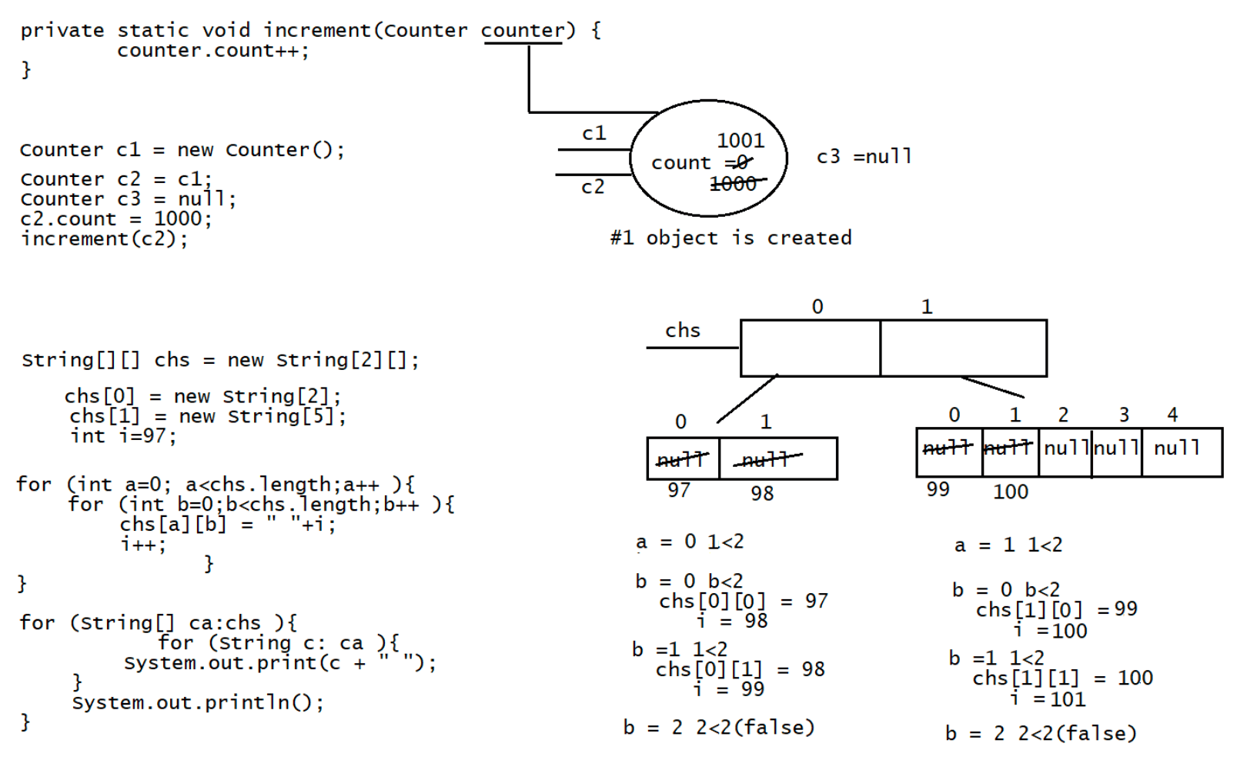
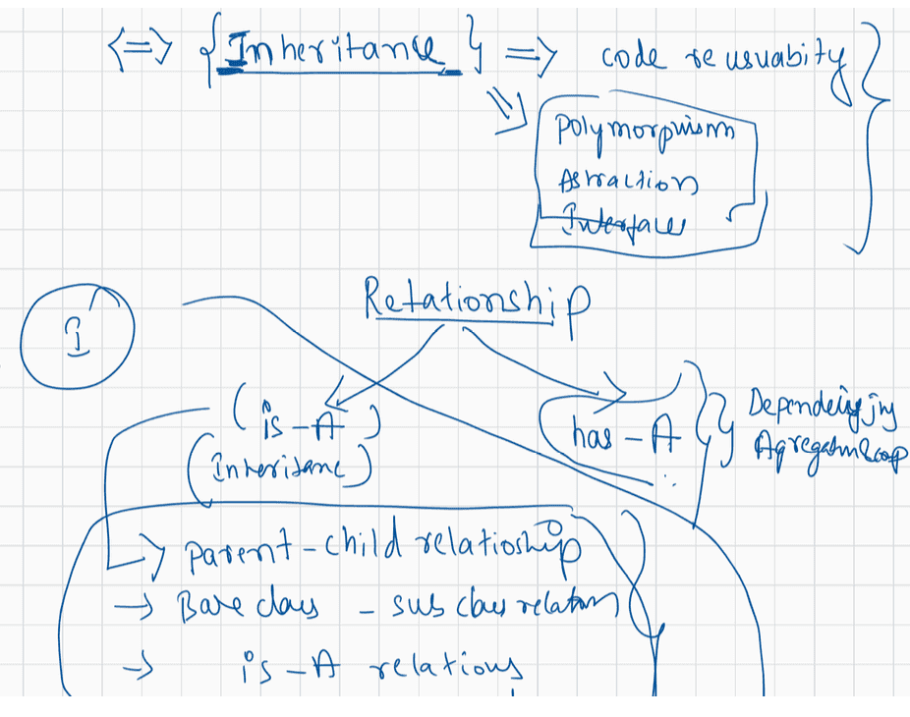
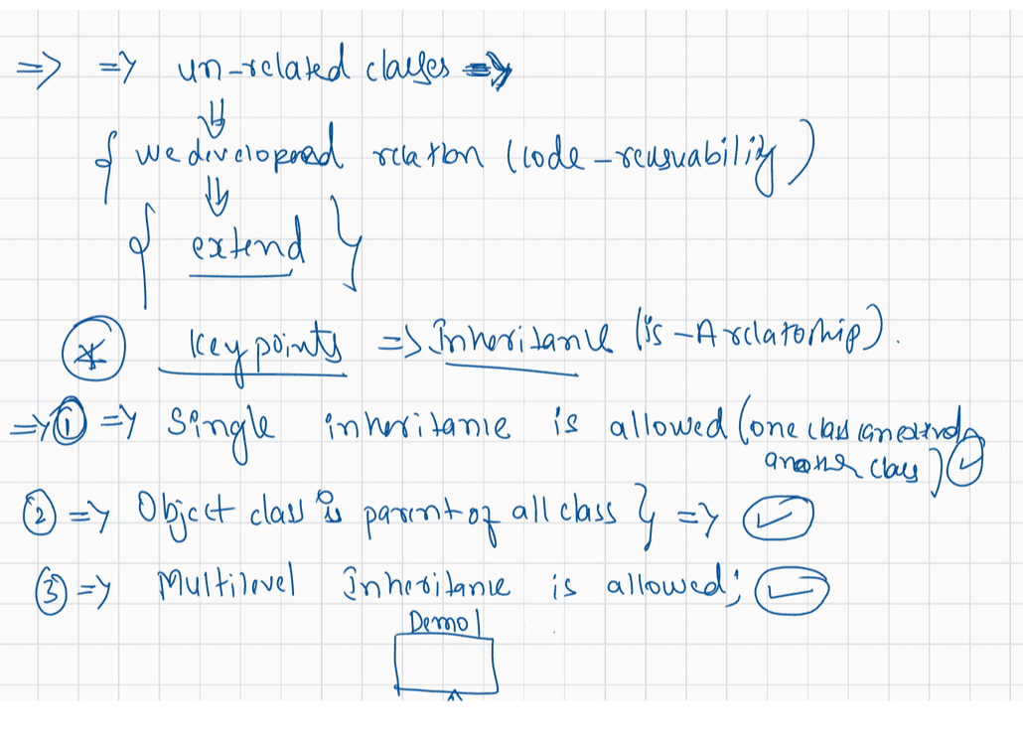
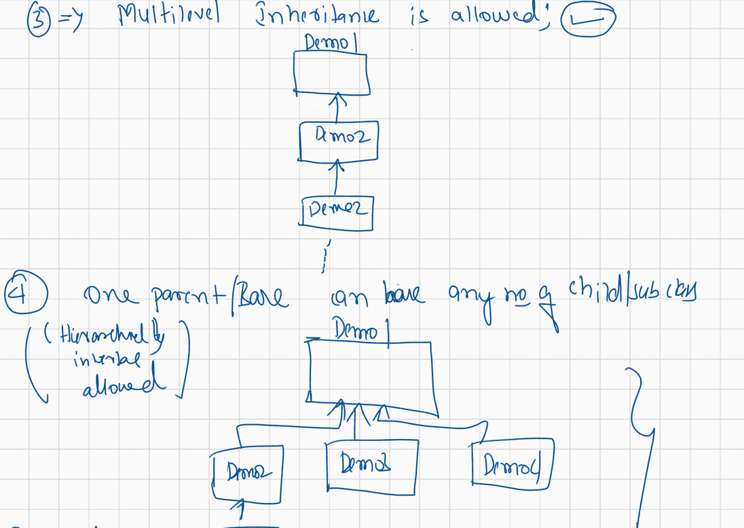
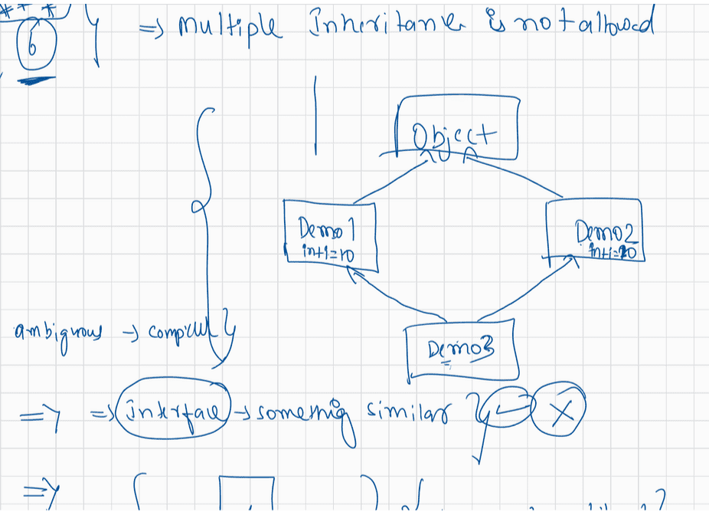
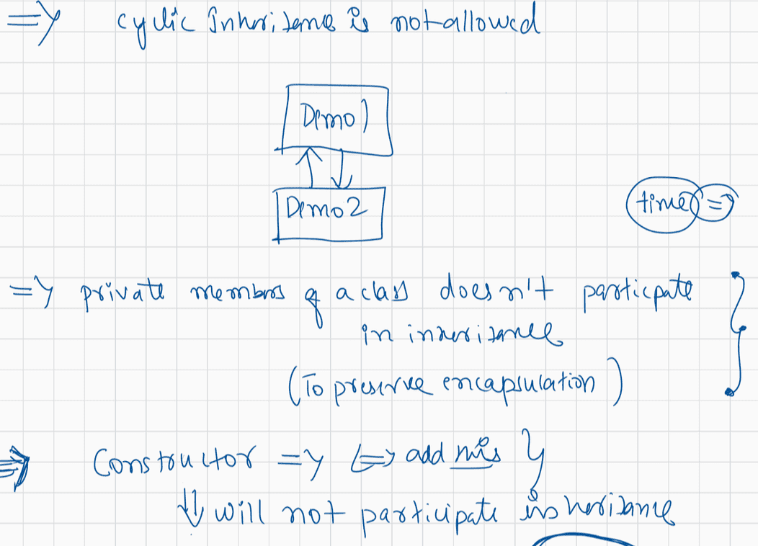

034 DOUBT

contact details
============
haider : syedhyder@ineuron.ai
nitin : nitin@ineuron.ai
import java.util.Scanner;
class Two_Sum{
public int[] sum(int arr[],int target){
int[] index;
looop: for(int i =0 ;i<arr.length;i++){
for(int j=i+1;j<arr.length-1;j++)
{
int sum=arr[i]+arr[j];
if (sum==target){
System.out.println("[" + i+ ","+ j+"]");
index = new int[2];
index[0]=i;
index[1] = j;
break loop;
}
}
return index;
}
}
public static void main(String [] args){
Two_Sum obj= new Two_Sum();
int arr[]= new int[10];
Scanner sc= new Scanner(System.in);
for(int i=0 ; i<arr.length;i++){
arr[i]=sc.nextInt();
}
System.out.println("Enter the target element:");
int target=sc.nextInt();
obj.sum(arr,target);
}
}
Why Main method only accept String types of Arguments?
java Test sachin 10 IND
|
|
Test.main(new String[]{"sachin","10","IND"})
If the data is collected in String type, then we can covert the String object to
any type using "Wrapper classes".
class Test{
public static void main(String[] args){
}
}
Q>
Example 1:
Input: nums = [2,7,11,15], target = 9
Output: [0,1]
Explanation: Because nums[0] + nums[1] == 9, we return [0, 1].Q> once explain this keyword sir
class Student
{
//instance variables
String name; int age;
//local variables are name,age
Student(String name,int age)
{
this.name =name;
this.age = age;
}
}
Student std = new Student("sachin",10);
Note: when name clash occurs between local and instance variable, jvm will give
preference only for local variable this concept is called
as Shadowing.
this keyword holds the address of current object, so it resolves the name
clash b/w local and instance variables.
From your session on 3rd Nov: Immutability is the main disadvantage of SCP, got it.
But, on 1st Nov, you said creating String literal without newing up is the most
efficient way.
Could you please clarify that for me? Thanks in advance!
refer: adhar card application.
Q> What is the difference between static and non-static?
static => common for all the objects of a class.
nonstatic/instance => specific to particular object of a class.
Q>
can you explain about null ...null is belong to which category like object or
primitive type or string like that..who is null?
Object variable we call as reference default value is null.
eg: String name = null;
Integer i = null;
Q> Sir Can you discuss about static control flow.
class Test{
static int i;// memory will be located in method area , it will be loaded at
the time of loading .class file
int j;
static
{
System.out.println("Test .class file is loading");
i =10;
}
//instance block will be executed
{
j = 20;}
//constructor will be executed
public Test()
{
j = 100;
}
}
Test t = new Test();
1 . load the .class file
2. during the loading of .class file memory for static variable will be given with
default value
3. static block will be executed
4. instance block will be executed
5. constructor will be executed.
Q> when to use static method and when to use non static method?
static method => helper method/ utility methods, if we want to give
facility of the logic to the user
without creating the objects of its class then make
such methods as "static".
object to create and then
non-static-method => normally the methods will be non-static as we need the
get the service of the method.
Q> explain about pass by value and pass by reference
int a = 10;
int b = 20;
add(a,b);//pass by value becoz we are sending primitive type data
10 20
public void add(int x, int y)
{
System.out.println("The sum is :: "+(x+y));
}
pass by reference
===============
Student s1 =new Student();
Student s2 =new Student();
validate(s1,s2);//pass by reference as we are sending the object type
public void validate(Student x,Student y)
{
}
Encapsulation
===========
Process of keeping the data member private and exposing those value to the
outer world through methods is called "encapsulation".
public class Student
{
private String name;
public Student(String name){this.name =name;}
public void setName(String name){this.name =name;}
public String getName(){return name;}}

035 Inheritance ,(inherited vs overridden vs specialised methods) super, final keyword in Java
Q>
class A {
public String toString() {
return null;
}
}
public class Test {
public static void main(String [] args) {
String text = null;
text = text + new A(); //Line n1 "nullnull"
System.out.println(text.length()); //Line n2
// JVM text = null + "null" text =
}
}
A. Line n1 causes compilation error
B. Line n1 causes Runtime error
C. Line n2 causes RunTime error
D. 0
E. 4
G. 8
Answer: G
Consider below code:
//Test.java
class SpecialString {
String str;
SpecialString(String str) {
this.str = str;
}
}
public class Test {
public static void main(String[] args) {
Object [] arr = new Object[4];
for(int i = 1; i <=3; i++) {
switch(i) {
case 1:
arr[i] = new String("Java");
break;
case 2:
arr[i] = new StringBuilder("Java");
break;
case 3:
arr[i] = new SpecialString("Java");
break;
}
}
for(Object obj : arr) {
System.out.println(obj);
}
}
}
A. Java
Java
Java
B. Java
Java
What will be the result of compiling and executing Test class?Some text with @symbol
C. Java
Some text with @symbol
Some text with @symbol
D. null
Java
Java
Java
E. null
Java
Java
Some text with @symbol
F. null
Java
Some text with @symbol
Some text with @symbol
G. Java
Java
Java
null
H. Java
Java
Some text with @symbol
null
I. Java
Some text with @symbol
Some text with @symbol
null
Answer: E
Q> .
{
class MyStringClass extends String
String name;
}
Output: CompileTime Error
Q>
String name = "sachinrameshtendulkar".substring(4);
System.out.println(name);//inrameshtendulkar
Q> .
String s = "1".repeat(5);
System.out.println(s);//11111
Q>.
System.out.println("1".concat("2").repeat(5).charAt(7));
1212121212.charAt(7) - > 2
Q>
operator?
String
StringBuffer
StringBuilder
Answer: String
To which of the following classes, you can create objects without using newQ> .
String string = "string".replace('i', '0');
System.out.println(string.substring(2, 5));
string = "strOng";
output: rOn
Q> .
In my application, I want mutable and thread safe string objects. Which class do
you refer me to use? String or StringBuffer or StringBuilder?
Answer StringBuffer(synchronized)
Q> .
System.out.println("Java" == new String("Java"));//false
Q>
".strip();
java
String str = " Ineuron\tTechnology\tPrivateLimited\tKnown\tfor\tjava
System.out.println(str);// Ineuron Technology PrivateLimited Know for
Q> .
{
if("string".toUpperCase() == "STRING")
System.out.println(true);
}
else
{
System.out.println(false);
}
Answer: false(comparison happened b/w heap area object and SCP)
Q> .
True or False?
Answer: Yes
String, StringBuffer and StringBuilder – all these three classes are final classes.
Q> .
String str1 = "1";
String str2 = "22";
String str3 = "333";
System.out.println(str1.concat(str2).concat(str3).repeat(3));
Answer: "122".concat("333")
"122333".repeat(3)
122333122333122333
Q>Ronaldo is developing an application in which string concatenation is very
frequent.
be thread safe.
Which string class do you refer him to use? And also he doesn’t need code to
StringBuilder(1.5V)
Q>.
System.out.println("Java"+1000+2000+3000); // "java1000"+2000+3000 =>
"java10002000" + 3000 => "java100020003000"
Q>.
System.out.println(1000+2000+3000+"Java");//3000+3000+"java" => 6000+"java"=>"6000java"
Q>.
System.out.println(7.7+3.3+"Java"+3.3+7.7);//11.0 + "java" + 3.3 +7.7 => "11.0
java"+3.3 => "11.0java3.3" + 7.7 => "11.0java3.37.7"
Q>.
System.out.println("ONE"+2+3+4+"FIVE");//"ONE2" + 3+4+"FIVE" => "ONE23" + 4
+"FIVE"=> "ONE234+" Five" => "ONE234Five"
Q>.
String s1=" ";
System.out.println(s1.isBlank());//true
System.out.println(s1.isEmpty());//false
Q>.
String s2="sachin ramesh tendulkar";
System.out.println(s2.substring(8, 4));
A. CE
B. rame
C. in ram
D. NullPointerException
E. StringIndexOutOfBoundsException
F. ArrayIndexOutOfBoundsException
Answer: E
Q>.
String s1 = new String("JAVA");
String s2 = new String("JAVA");
System.out.println(s1 == s2);
System.out.println(s1.equals(s2));
System.out.println(s1 == s2.intern());
System.out.println(s1.intern() == s2.intern());
System.out.println(s1.intern() == s2);

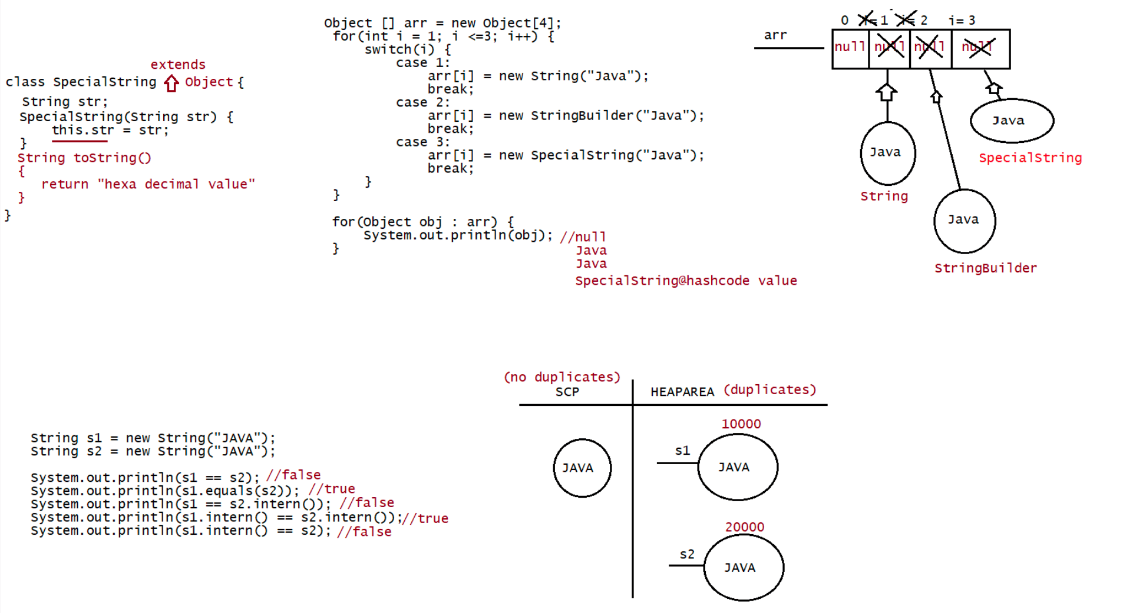
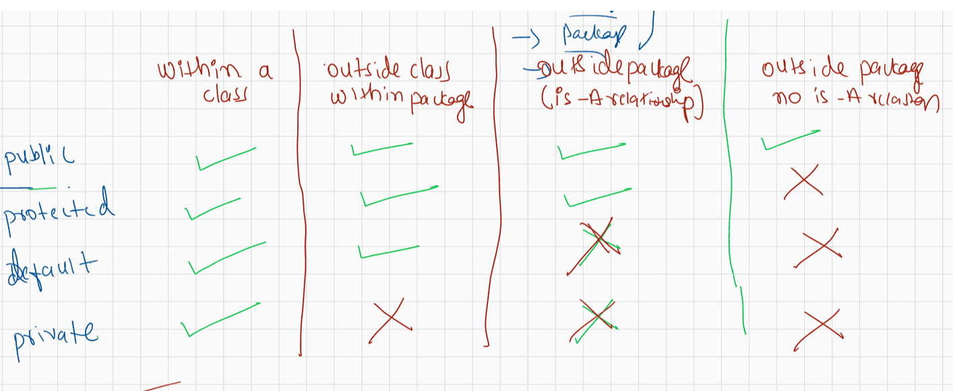
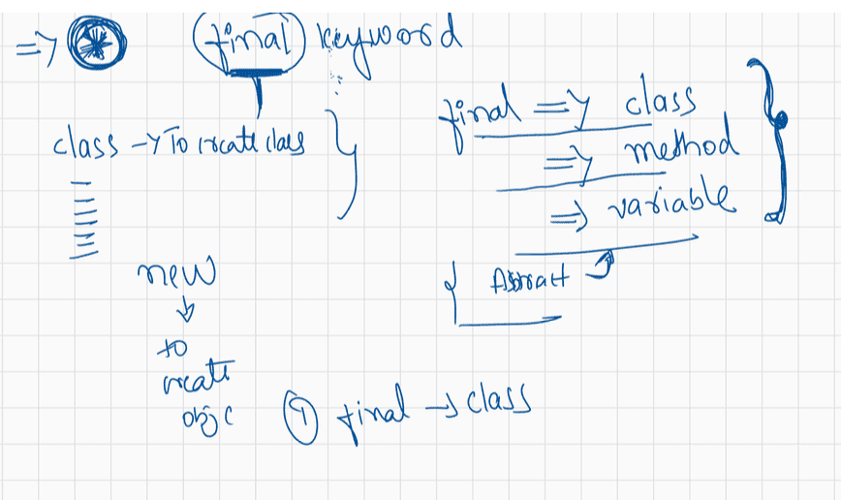
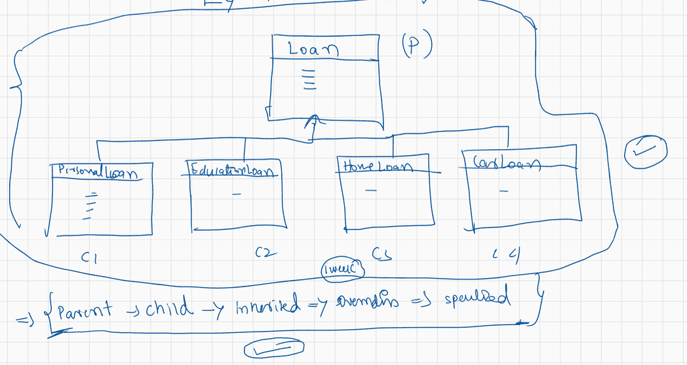
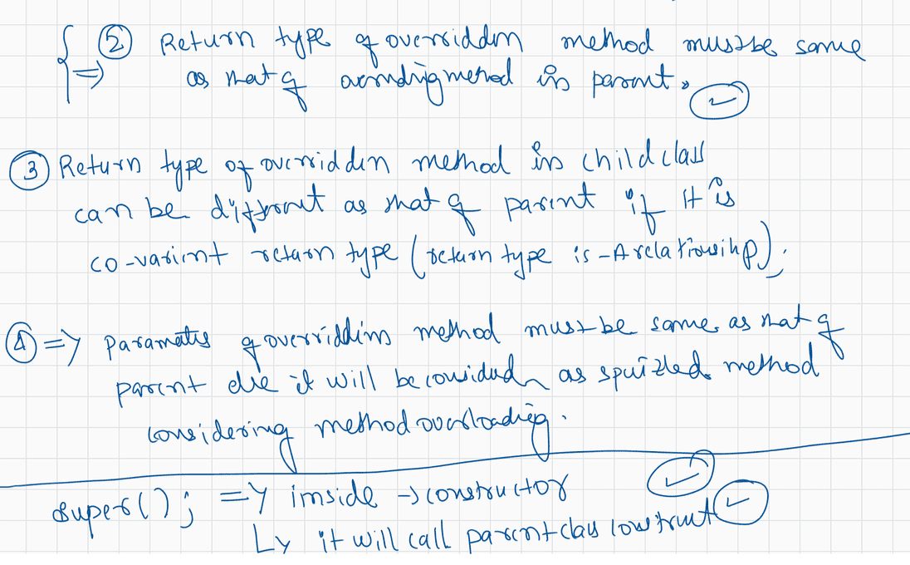
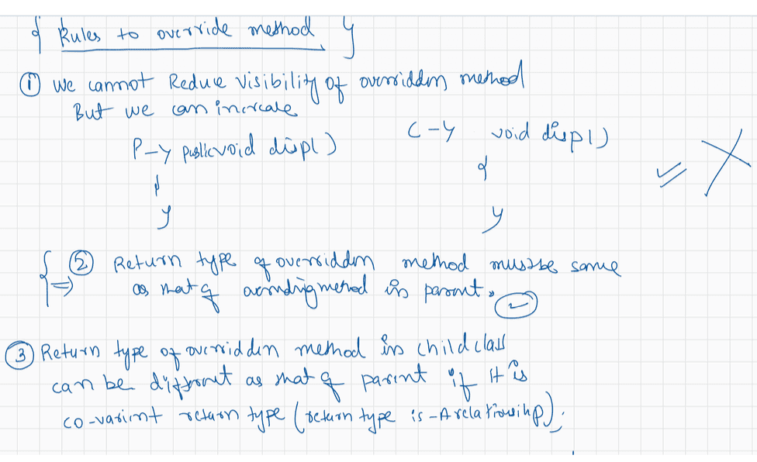
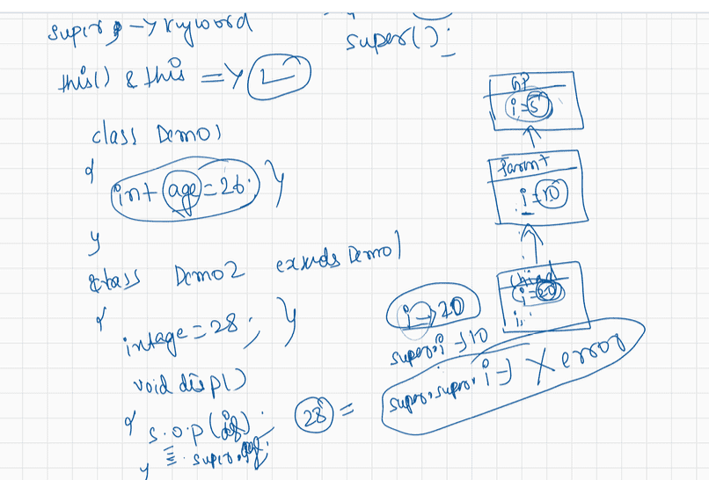
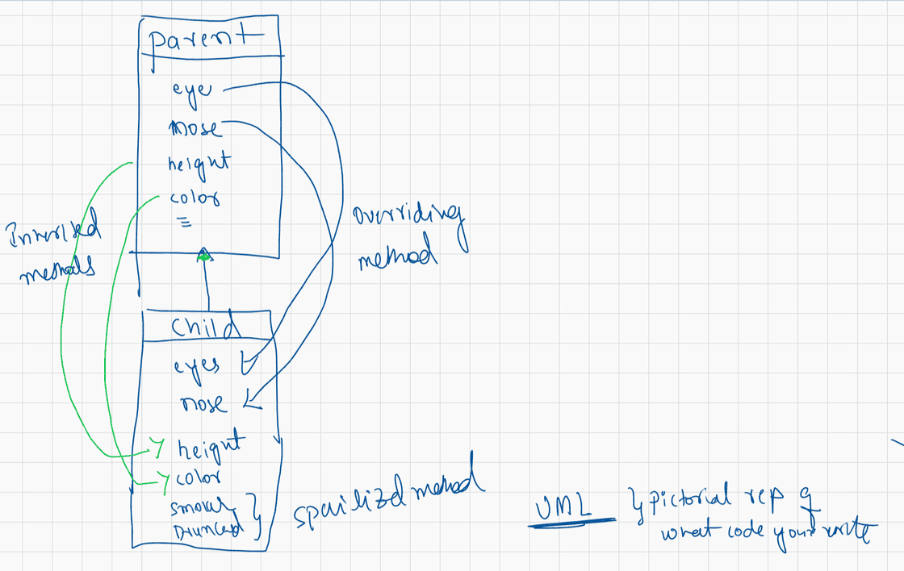
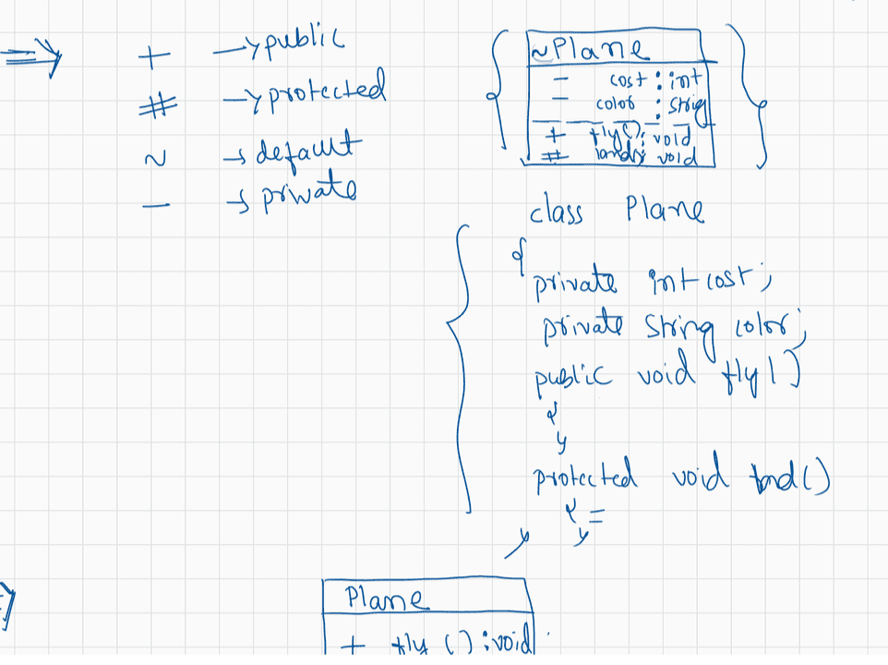

036 Polymorphism and abstract keyword in Java

Today discussion is QA(doubts resolving) not live session
Doubt discussion : wednesday( 2PM to 4PM IST)
saturday (6PM IST to 8PM IST)
next live class on : Monday(7.30PM IST to 10.30PM IST)
email id : nitin@ineuron.ai
syedhaider@ineuron.ai
----------------------------------------------------------------------------
Q>
what is jar files?
Collection of .class files we represent as Jar files(Java Archieve file).
Q>
which editor I used for java program and how to use eclipse for java program
editor -> Editplus /notepad
IDE -> using Eclipse,later we move to STS(Spring tool Suite)
Q>what is the difference between method and main method?
main method -> it is a method from where the jvm would start the
execution.
method -> set of instructions written by programmer.
Q> yesterday snippet 4 private cls and arguments
private class Demo{
public static void main(String[] args){
System.out.println(args[1]);
}
}
should be under public)
java Demo Good morning guys
javac Demo.java //Compile time Error(file name which contains main()
Q> please tell me the concept of (String [] agrs)
It will discussed when we talk on "Arrays" ,followed by "String"
class.
The data will be stored inside the args in the form of String and
it is an Array.
Q>byte ab=10; // data compiler by default treats as int,but in the range of byte so
no problem
byte ac=2; // data compiler by default treats as int,but in the range of byte so no
problem
byte result = ab*ac;// when we perfom the operation compiler is designed to store
the data in the higher
datatype of the specific type
eg: byte(1),short(2),int(4)
int result = byte * byte
----->type promoted to int
System.out.println(result);
Q> sir whatis differenc in git master and main .yesterday I was uploading a file on
GitHub and
it was not uploading with git push -u origin main .bit it worked with git
push -u master?
ans. branch names they are, it will taught moving further.
Q> sir in one interview , interviewer asked me what is the diff b/w a=a+1 and a++?
byte a = 10;
a = a + 1;//CE:possible loss of precession
System.out.println(a);stored
byte a = 10;//JVM will give memory of 1 byte and data 10 is
a++;//no problem for compiler
// a = (byte)(a+1);//11 will be stored as a byte by the JVM
System.out.println(a);
byte a = 10;
discussed,no problem for compiler
a+=1;//Short hand operator in operators topic it will
and jvm will resolve it through explicit
typecasting.
System.out.println(a);
Q> sir what will happen if we add multiple main methods ?
a. can we write mulitple methods with same name in a single class
class Test
{
public static void main(String[] args)
{
System.out.println("hiee");
}
{
public static void main(String[] args)
System.out.println("hello");
}
}
output: CompileTime Error
Q> Sir why the 'S' in system and ' S' in string is in upper case letter. can you
explain it?
reserved words -> It should start with lower case(convention followed
by Oracle team)
ClassName/interface name -> It should start with Upper case.(convention
followed by Oracle team).
int,float,double -> reserve words so lower case
String,System -> class name so upper case
Q> sir can we write class without main method means like empty class?
Ans. yes, possible but that file can't be given to jvm (java FileName).
If we give it would result in "Exception" as main method not
found.
Q> what if variable name and reserve keywords got same in same program?
int int a = 10; //CE: becoz reserve words can't be used as a
identifier/varaible name
Q> sir if we use class name first letter in small case will it be a problem?
No problem ,but as a good practise follow the convention to avoid the
disturbance in readability
eg: class Test{}//code is as per Convention(experience developers code)
class test{}//code is not per Convention(inexperienced developers
code)
Q>
sir what is difference between top down and bottom up approach in progammingApproach towards solving the code in realtime.(DSA part it is)
Q>
Hi Nitin, byte is able to store 1 byte of memory but char can store 2 bytes
of memory so internal typecasting won't be happened. but why it haven't throw error
in byte code
byte b='a'; as right side value will be assigned to b.
byte ----> 1 byte
char ----> 2 byte
Compiler is desinged to this type of conversion so we call this as "Implicit type
casting".
float ---------> double
byte------------> short -------------> int -------------> long ----------->
^
|
|
char(2 bytes) ====> to
support "Internationalization"
Internationlization -> Supporting the application to the end users as per there
country regional language.
Reverse of it if has to be done then programmer should write the statement of
casting it is called as
"Explicit type casting".
Q> sir why always it is necessary to define the main method as 'static' ?
JVM should call main method without creating the Object.
if a method is marked as static then that method would be called using
ClassName
So we want jvm to call main method using className so mark main() as
"static

Consider below code of Test.java file:
public class Test {
public static void main(String[] args) {
for(int i = 5; i >= 1; i--) { //Line n1
System.out.println("*".repeat(i)); //Line n2
}
}
}
A. *
**
***
****
*****
What will be the result of compiling and executing Test class?
B. *****
****
***
**
*
C. *
**
***
****
D.
****
***
**
*
E. compilationError
F. Line n2 cause runtimeerror
Answer : B
Q>
public static void main(String... args) {
boolean opt=true;//line5
switch (opt){
case true://line7
System.out.print("True");
break;//line9
default:
System.out.println("****");
}
System.out.println("Done");
}
What modification should be enabled to print TrueDone?
A. Replace line 5 with String opt="True"
Replace line 7 with case "True".
B. Replace line 5 with boolan opt=1
Replace line 7 with case 1=
C. At line 9 remove break statementD. Remove the default section.
Answer: A
Q>
public static void main(String... args) {
int x=5; //line4
while (isAvailable(x)){//line5
System.out.println(x);//line6 x= x-1 :: 54321
//line7
}
}
public static boolean isAvailable(int x){
return x-- > 0 ? true :false;//line8
}
What modification should be enabled the code to print 54321
A. Replace line 6 with System.out.print(x--);
B. At line 4 insert x--
C. Replace line 6 with --x and line 7,insert System.out.print(x)
D. Replace line 8 with return (x>0) ? false:true
Answer: A
Q>
JVM:: x-- , first use x and then
public static void main(String... args) {
StringBuilder sb=new StringBuilder(5);
String s="";
if (sb.equals(s)){
System.out.println("Match 1");
}else if(sb.toString().equals(s.toString())){
System.out.println("Match 2");
}else{
System.out.println("Match 3");
}
}
A. Match 1
B. Match 2
C. CompileTime Error
D. Match3
E. NullPointerException
Answer: B
Q>
Consider below code of Test.java file:
public class Test {
public static void main(String [] args) {
String text = "RISE ";
text = text + (text = "ABOVE ");
System.out.println(text);
}
}
What will be the result of compiling and executing Test class?
A. RISE RISE ABOVE
B. RISE ABOVE
C. ABOVE ABOVE
D. RISE ABOVE RISEAnswer: B
Q>
What will be the result of compiling and executing Test class?
public class Test {
public static void main(String[] args) {
StringBuilder sb = new StringBuilder("Java");
String s1 = sb.toString();
String s2 = "Java";
System.out.println(s1 == s2);
}
}
A. compilation error
B. true
C. false
D. An exception is thrown at runtime
Answer: C
Q>
public class Test {
public static void main(String[] args) {
StringBuilder sb = new StringBuilder("Java");
String s1 = sb.toString();
String s2 = sb.toString();
System.out.println(s1 == s2);
}
}
A. compilation error
B. true
C. false
D. An exception is thrown at runtime
Answer: C
Q>
public class Test {
public static void main(String[] args) {
String str = "java";
StringBuilder sb = new StringBuilder("java");
System.out.println(str.equals(sb) + ":" + sb.equals(str));
}
}
A. Compilation Error
B. false:false
C. false:true
D. true:false
E. true:true
Answer: B
Q>
transfers.
An example of swift code: ICICINBBRT4
ICIC: First 4 letters for bank code
IN: Next 2 letters for Country code
BB: Next 2 letters for Location code
A bank's swift code is generally of 11 characters and used in international moneyRT4: Next 3 letters for Branch code
Which of the following code correctly extracts country code from the swift code
referred by String reference variable swiftCode?
A. swiftCode.substring(4,6);
B. swiftCode.substring(5,6);
C. swiftCode.substring(5,7);
D. swiftCode.substring(4,5);
Answer: ICICINBBRT4
A. swiftCode.substring(4,6);
Q>
public class Test {
public static void main(String[] args) {
StringBuilder sb = new StringBuilder();
System.out.println(sb.append(null).length());
}
}
A. NullPointerException
B. 1
C. 4
D. CompilationError
append(String)
append(StringBuilder)
append(StringBuffer)
Answer: D
Q>
public class Test {
public static void main(String[] args) {
StringBuilder sb = new StringBuilder();
System.out.println(sb.append("").append("").append("").length());
}
}
A. 0
B. 1
C. 2
D. 3
Answer: A(0)
Q>
public class Test {
public static void main(String[] args) {
StringBuilder sb = new StringBuilder(5);// capacity = 5 ,new capacity =
(5+1) * 2 = 12
sb.append("0123456789");
sb.delete(8, 1000);
System.out.println(sb);
}
}
A. CompilationError
B. An Exception is thrown at Runtime
C. 01234567
D. 89Answer: C
Q>
public class Test {
public static void main(String[] args) {
StringBuilder sb = new StringBuilder("Hurrah! I Passed...");
sb.delete(0, 100);
System.out.println(sb.length());
}
}
A. 19
B. 0
C. 16
D. StringIndexOutOfBoundsException
Answer: B
Q>
public class Test {
public static void main(String[] args) {
StringBuilder sb = new StringBuilder(100);
System.out.println(sb.length() + ":" + sb.toString().length());
}
}
A. 100:100
B. 100:0
C. 16:16
D. 16:0
E. 0:0
What will be the result of compiling and executing Test class?
Answer: 0:0

037 DOUBT
Good Afternoon guys,
Post ur Questions in QA i will answer.
contact details
hyder: syedhyder@Ineuron.ai
niitn : nitin@Ineuron.ai
Q> when a String having null value give null point Exception and when it will treat
null as a value ?
String name = null;
System.out.println(name.toUpperCase());// NullPointerException
vs
String name = "null";
System.out.println(name.toUpperCase());//NULL
Q>I'm having a small doubt about constructor chaining.
Answer:
class Object
{
Object()
{
}
}
class Parent extends Object
{
Parent()
{
super();
}
}
class Child extends Parent
{
Child()
{
super();
}
}
new Child();
Q>
{
class Account implements Serializable
private String name = "sachin";
transient private String pwd = "123";
private void writeObject(ObjectOuputStream oos)
{
oos.defaultWriteObject();//name = sachin, pwd = null
String encypwd = 1234+pwd;
oos.writeObject(encypwd);// ObjectOuputStream class writeObject() will
be called encypwd= "1234123"}
{
private void readObject(ObjectInputStream oos)
ois.defaultReadObject();//name = sachin, pwd = null
String decrypwd= (String)ois.readObject(encypwd);
pwd = decrypwd.substring(3);//123
}
}
Account acc =new Account();
ObjectOutputStream oos=new ObjectOutputStream(fos);
oos.writeObject(acc);// jvm will check whether the Account class contains
writeObject(ObjectOutputStream)
if it is not available in Account class then
jvm will call ObjectOutputStream writeObject().
Q>
String s1=null;
String s2=null;
System.out.println(s1+s2);//System.out.println(null+null); // nullnull
System.out.println(s1.concat(s2));//NPE
Q>
sir in inheritance i was created object to child class and same variable present in
both classes like (int a ,int b)
with diiferent values and one add() in parent class. when i invoke that method it
will give sum of
variables present in parent class not in child class sum
class Parent
{
add(){
}
add(int a,int b){
}
}
class Child extends Parent{
add(int a,int b){
}
}
Parent p = new Child();
p.add(10,20);// if overriden then based on runtime object method will be called.
// if overloaded then based on compile time reference method will
be called.
Q>
Sir there was interview question like In how many ways we can define loose
coupling?
1. Parent ref =new Child();
2. class Demo{
public void test(Parent p){
;;;;
;;;;
}}
3. class Demo{
public Parent test(){
;;;;
;;;;
}
}
Q>
what is the value ar[s1.charAt(i)]++; ????

038 HAS Relationship and dependancy injection
Dependancy Injection
==================
The process of injecting dependant object into target object is called as
"Dependancy injection".
We can achieve dependancy injection in 2 ways
a. Constructor dependancy injection
b. Setter dependancy injection
a. Constructor dependancy Injection
Injecting dependant object into target object through a constructor is called
as "Constructor Dependancy Injection".
b. Setter dependancy Injection
Injecting dependant object into target object through a setter is called as
"Setter Dependancy Injection".
eg#1
class Engine { //Dependant Object
}
class Car{//Target Object
//HAS-A relationship
Engine engine ; //instance variable
}
eg#2
class Address{//Dependant Object
}
class Student {//Target Object
//HAS-A relationship
Address address; //instance variable
}
eg#3
class Account{//Dependant Object
}
class Employee {//Target Object
//HAS-A relationship
Account account;//instance variable
}
Relationships in JAVA
==================
As part of Java application development,we have to use entities(class) as per the
application requirements.
In Java application development,if we want to provide optimizations over memory
utilization,code Reusability, Execution Time,Sharability
then we have to define relationships between entities.
There are three types of relationships between entities.
1.Has-A relationship (extensively used in projects)
2.IS-A relationship (achieved using extends keyword)
3.USE-A relationship(not popular)Q)What is the difference between HAS-A Relationship and IS-A relationship?
Ans:
Has-A relationship will define associations between entities(class) in Java
applications,here associations between entities will
improve communication between entities and data navigation between entities.
IS-A Relationship is able to define inheritance between entity classes, it will
improve "Code Reusability" in java applications.
Associations in JAVA
================
There are four types of associations between entities
1.One-To-One Association(1:1)
2.One-To-Many Association (1:M)
3.Many-To-One Association (M:1)
4.Many-To-Many Association (M:M)
To achieve associations between entities,we have to declare either single reference
or array of reference variables of an entity class in
another entity class.
class Address{
----
}
class Account{
----
}
class Employee{
----
Address[] addr;//It will establish One-To-Many Association (1:M)
Account account; // One-To-One Association(1:1)
}
1.One-To-One Association:
It is a relation between entities, where one instance of an entity should be mapped
with exactly one instance of another entity.
eg: Every employee should have exactly one Account.
eg: refer:: 02-One-One-Association-mapping
2.One-To-Many Association:
It is a relationship between entity classes, where one instance of an entity should
be mapped with multiple instances of another entity.
Example:Single department has multiple employees.
eg: refer:: 03-One-MANY-Association-mapping
Many-To-One Association:
=====================
It is a relationship between entities,where multiple instances of an entity should
be mapped with exactly one instance of another entity.
EX:Multiple Student have joined with a single branch.
eg: refer:: 04-MANY-ONE-Association-mappingMany-To-Many Associations
=======================
It is a relationship between entities,Where multiple instances of an entity should
be mapped with multiple instances of another entity.
EX:Multiple Students Have Joined with Multiple Courses
eg: refer:: 05-MANY-MANY-Association-mapping

Consider below code:
//Test.java
public class Test {
public static void main(String[] args) {
final int i1 = 1;
final Integer i2 = 1;//memory will be decied at the runtime becoz it is
wrapper class Object
final String s1 = ":ONE";
String str1 = i1 + s1;// Compiler :: 1 + :ONE => 1:ONE
String str2 = i2 + s1;// Compiler :: i2 + :ONE
System.out.println(str1 == "1:ONE");//true
System.out.println(str2 == "1:ONE");//false
}
}
A. true
true
B. true
false
C. false
false
D. false
true
What will be the result of compiling and executing Test class?
Answer: B
Q>
Consider below code:
//Test.java
public class Test {
public static void main(String[] args) {
String javaworld = "JavaWorld";//SCP
String java = "Java";//SCP
String world = "World";//SCP
java += world;// JVM => Java+World => java = JavaWorld(heap area)
System.out.println(java == javaworld);
}
}
A. JavaWorld
B. Java
C. World
D. true
E. false
What will be the result of compiling and executing Test class?
Answer: E
Q>
What will be the result of compiling and executing Test class?
public class Test {
public static void main(String[] args) {
StringBuilder sb = new StringBuilder("SpaceStation");
sb.delete(5, 6).insert(5, " S").toString().toUpperCase();
System.out.println(sb);
}
}
A. SPACE STATIONB. SPACE SATION
C. Space Station
D. Space Sation
Q>
public class Test {
public static void main(String[] args) {
String s1 = "OCP";
String s2 = "ocp";
System.out.println(/*INSERT*/);
}
}
Which of the following options, if used to replace /*INSERT*/, will compile
successfully and on execution will print true on to the console?
Select 2 options.
A. s1.equals(s2)
B. s1.equals(s2.toUpper())
C. s1.equals(s1.toLower())
D. s1.length()==s2.length()
E. s1.equalsIgnoreCase(s2)
Answer: D,E
Q>
Consider below code of Test.java file:
public class Test {
public static void main(String [] args) {
String text = "ONE ";
System.out.println(text.concat(text.concat("ELEVEN ")).trim());
}
}
What will be the result of compiling and executing Test class?
A. ONE ELEVEN
B. ONE ONE ELEVEN
C. ONE ELEVEN ONE ELEVEN
D. ONE ELEVEN ONE
Anser: B
Q>
Consider below code of Test.java file:
public class Test {
public static void main(String[] args) {
String str = "PANIC";
StringBuilder sb = new StringBuilder("THET");
System.out.println(str.replace("N", sb)); //Line n1
}
}
What will be the result of compiling and executing Test class?
A. PATHETIC
B. PANIC
C. Line n1 causes compile time error
D. Line n1 cause runtime error.
Answer: PATHETIC
Q>
Consider below code of Test.java file:
public class Test {public static void main(String[] args) {
boolean flag1 = "Java" == "Java".replace('J', 'J'); //Line n1
boolean flag2 = "Java" == "Java".replace("J", "J"); //Line n2
System.out.println(flag1 && flag2);
}
}
What will be the result of compiling and executing Test class?
A. Line n1 causes compilation error.
B. Line n2 causes compilation error.
C. true
D. false
Answer: C
Q>
Consider below code fragment:
String place = "MISSS";
System.out.println(place.replace("SS", "T"));
What is the output?
A. MIST
B. MITS
C. MISSS
D. MIT
Answer: B
Q>
Consider below code of Test.java file:
public class Test {
public static void main(String[] args) {
String str = "ALASKA";
System.out.println(str.charAt(str.indexOf("A") + 1));
}
}
A. A
B. L
C. S
D. K
E. RuntimeError
Answer: B
Q>
What will be the result of compiling and executing Test class?
public class Test {
public static void main(String[] args) {
StringBuilder sb = new StringBuilder("TOMATO");
System.out.println(sb.reverse().replace("O", "A")); //Line n1
}
}
A. TOMATO
B. TAMATO
C. TAMATA
D. OTAMOT
E. OTAMAT
F. ATAMAT
G. Compilation Error
What will be the result of compiling and executing Test class?Answer: G
Q> .
Serializable
CharSequence
Comparable
All of the above
Answer: All the above
java.lang.String class implements which of the following interfaces?
51.
3);
String[] strings = "iNeuron_Technology_privatelimited_Known_For_Java".split("_",
for (String string : strings)
System.out.println(string);
Answer:iNeuron
Technology
privatelimited_Known_For_Java

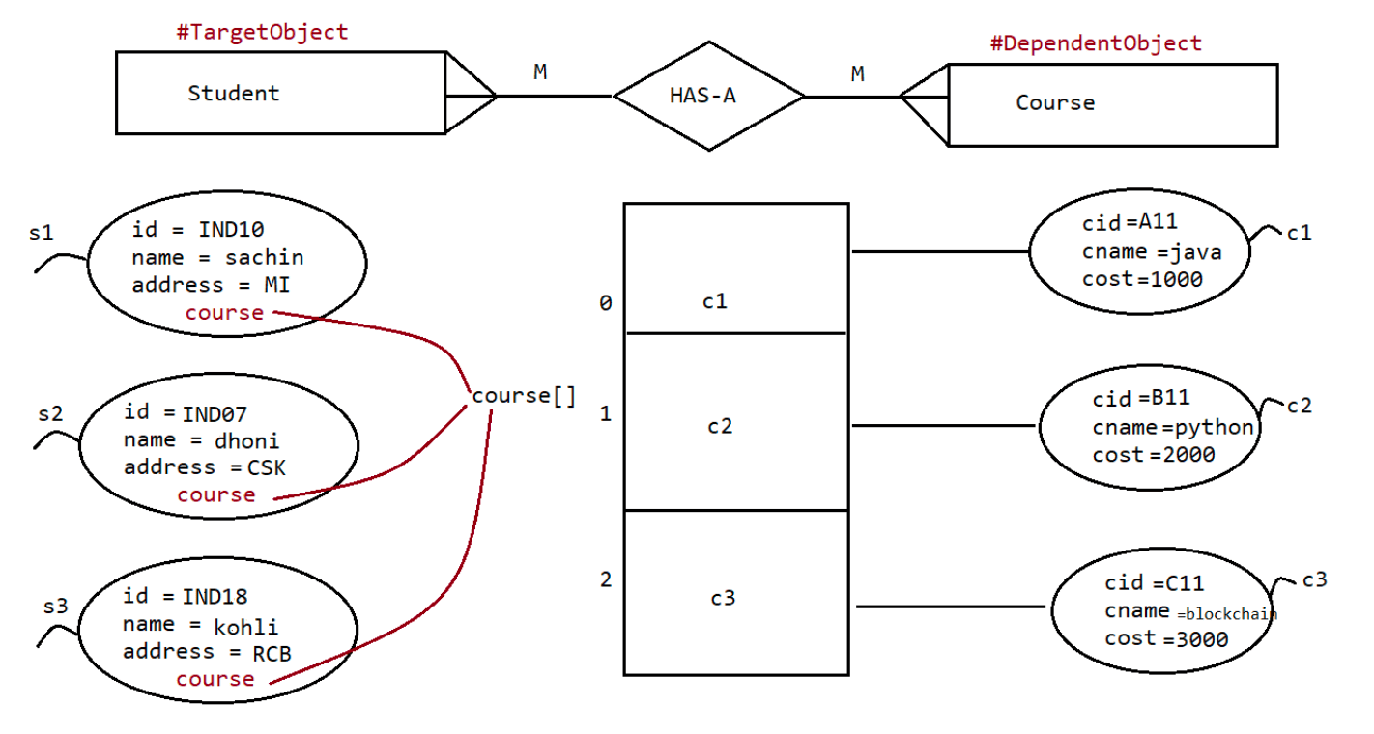
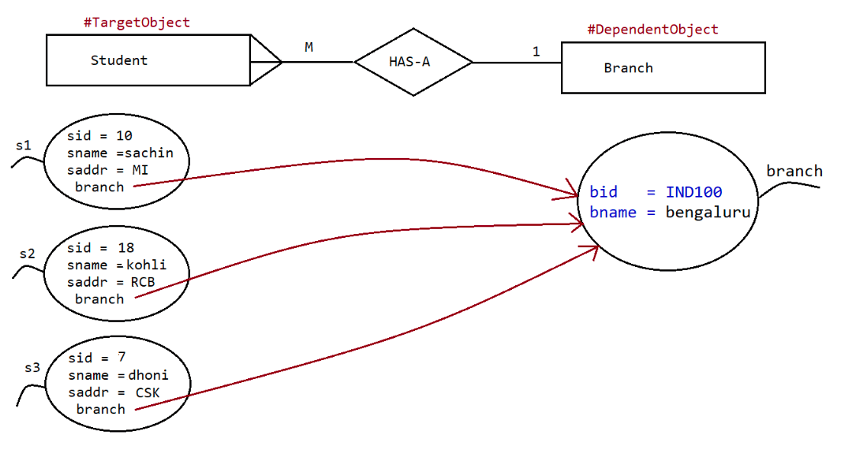
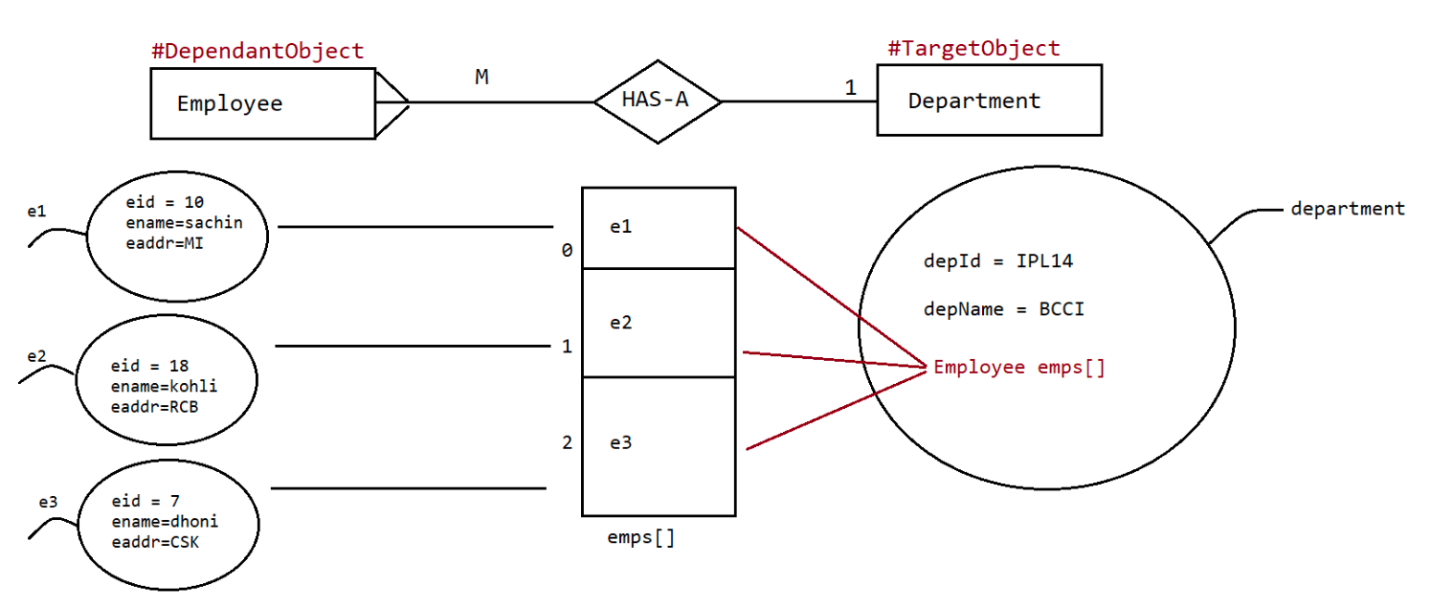
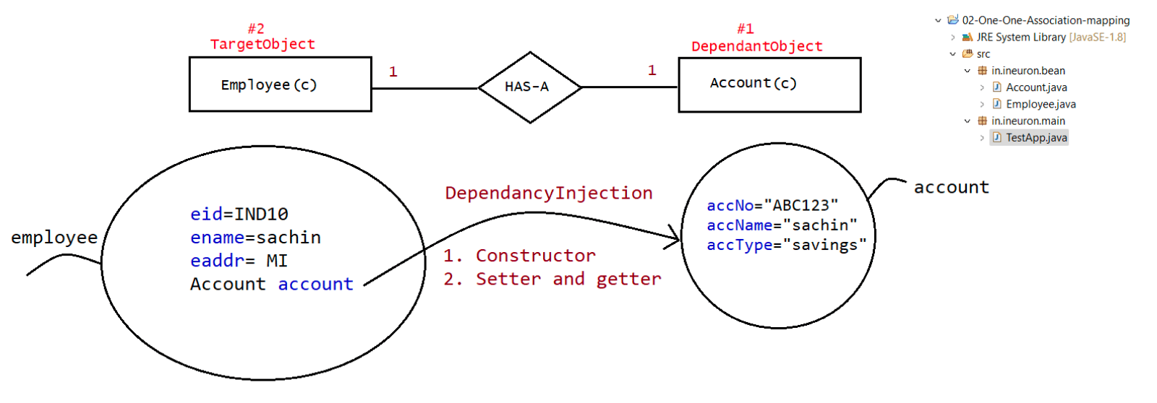
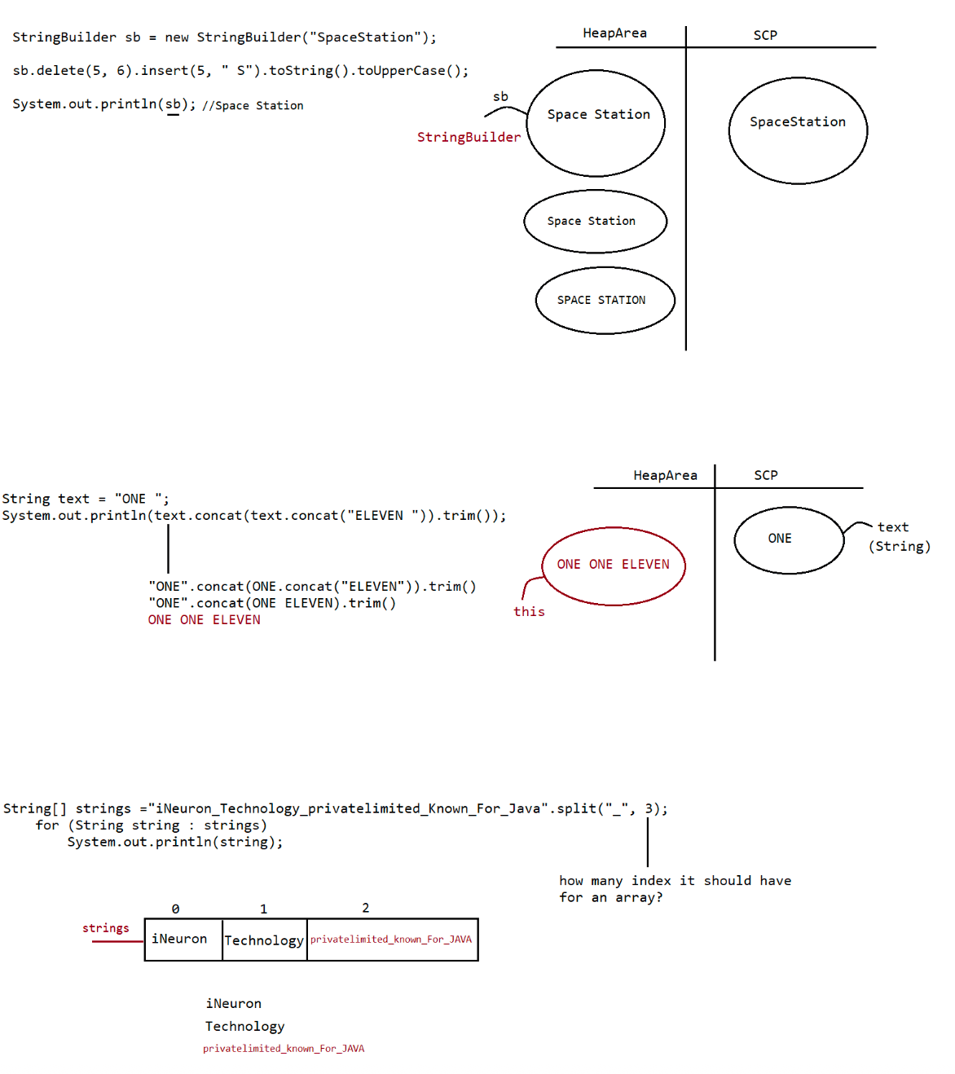

039 Inner class and introduction to interface
Interface
=======
Def1::Any service requirement specification(SRS) is called interface.
eg:: SUN people responsible to define JDBC API and database vendor will provide
implementation for that
SUN
|
JDBCAPI
|
Oracle MySQL PostgreSQL
===========================================
SUN
|
ServletAPI
|
tomcat weblogic jboss
===========================================
Def2::From client point of view an interface define the set of services what is
expecting.
From service provider point of view an interface define the set of
services what is "offering".
So interface acts a contract b/w client and serviceprovider.
eg:: GUI screen of ATM defines the set of services what the customer is
expecting,
Bank people offered the same set of services what the customer is
expecting.
Cusomter => GUI => Bank
Def3:: Inside interface every method is always abstract whether we are delcaring or
not hence interface is considered as
100% pure abstract class.
eg:
{
interface Account
//It is 100% abstract class
//The methods are by default "abstract and public"
void withDraw();
void deposit();
void checkBalance();
}
Summary::
Interface corresponds to Service Requirement Specification(SRS) or contract b/w
client and service provider or 100% pure abstract class.
Declaration and implementation of Interface
===========================================
a. Whenever we are implementing an interface compulsorily for every method of that
interface
we should provide implentation otherwise we have to declare class as abstract
class in that case child class is responsible to provide
implementation for remaining methods.b. Whenever we are implementing an interface method compulsorily it should be
declared as public otherwise it would result in
CompileTime Error.
eg:: interface ISample{
void methodOne();
void methodTwo();
}
abstract class Sample implements ISample{
public void methodOne(){...}
}
class SubServiceProvider extends Sample{
@Override
public void methodTwo(){...}
}

Q>
Which of these classes have delete() and reverse() method
java.lang.String, java.lang.StringBuffer and java.lang.StringBuilder?
ans: StringBuilder and StringBuffer
Q>
String str = " ";
System.out.println(str.isBlank());//true
System.out.println(str.isEmpty());//false
Q>java.lang.String class has append() method. Right or Wrong?
ans: False(we have concat())
Q>
String str = "iNeuron Technology private limited";
System.out.println(str.replace("a", "A").lastIndexOf('a'));
Answer: -1
Q>
String s1 = "1";
System.out.println(s1.concat("2").concat("3"));
Answer: 123
Q>
String s1 = "ONE";
s1.concat("TWO");
s1.concat("THREE");
System.out.println(s1);
Answer: ONE
Q>
String str1 = "Java";
String str2 = str1.intern();
String str3 = new String("Java");
System.out.println(str1 == str2);
System.out.println(str2 == str3);
System.out.println(str3 == str1);
Answer: true,false,false
Q>
String str1 = "Java";
String str2 = str1.intern();
System.out.println(str1 == str2);
System.out.println(str1.equals(str2));
Answer: true,true
Q>
StringBuffer sb1 = new StringBuffer("11111");
StringBuffer sb2 = sb1.append(22222).reverse();// sb1 ,sb2 =2222211111
System.out.println(sb1 == sb2);//true
Q>
StringBuffer and StringBuilder classes have intern() method. True or False?
answer: FalseQ>
System.out.println(String.join(",", "1", "2",
"3").concat(",").repeat(3).lastIndexOf(','));
output:: 1,2,3,1,2,3,1,2,3,
Answer: 17
Q>
String str1 = "OnE tWo ThReE fOuR";
String str2 = "oNeTwOtHrEeFoUr";
System.out.println(str1.trim().equalsIgnoreCase(str2));//false
Q>
StringBuffer sb = new StringBuffer("11111");
System.out.println(sb.insert(3, false).insert(5, 3.3).insert(7, "One"));
Answer: 111fa3.One3lse11
Q>
String str1 = "Java J2EE Spring Hibernate SQL";
String str2 = "Python Java Scala C C++";
System.out.println(str1.contains("HTML") == str2.contains("HTML"));
false == false
true
Answer: true
Q>
StringBuffer sb = new StringBuffer("One Two Three Four Five");
System.out.println(sb.reverse().indexOf("Two"));
Answer: -1
Q>
String str = null;
System.out.println(str.isBlank());//NullPointerException
Q>.
StringBuilder sb = new StringBuilder("0123456789");
System.out.println(sb.delete(3, 6).deleteCharAt(4).deleteCharAt(5));
Answer: 01268
Q>
String s1="sachinrameshtendulkar";
System.out.println(s1.replace('a', 'A').indexOf('a'));
Answer: -1
Q>.
String str = "ineuron Technology Private Limited";
System.out.println(str.indexOf('n', 5));
Answer: 6
Q>.
String str = "ineurontechnologyprivatelimited"; //length -> no of characters
System.out.println(str.charAt(str.length())); //charAt -> from the index 0.
Answer: StringIndexOutOfBoundsExceptionQ>.
StringBuilder sb = new StringBuilder(-32);
sb.append("ABC");
System.out.println(sb);
Answer: NegativeArraySizeException

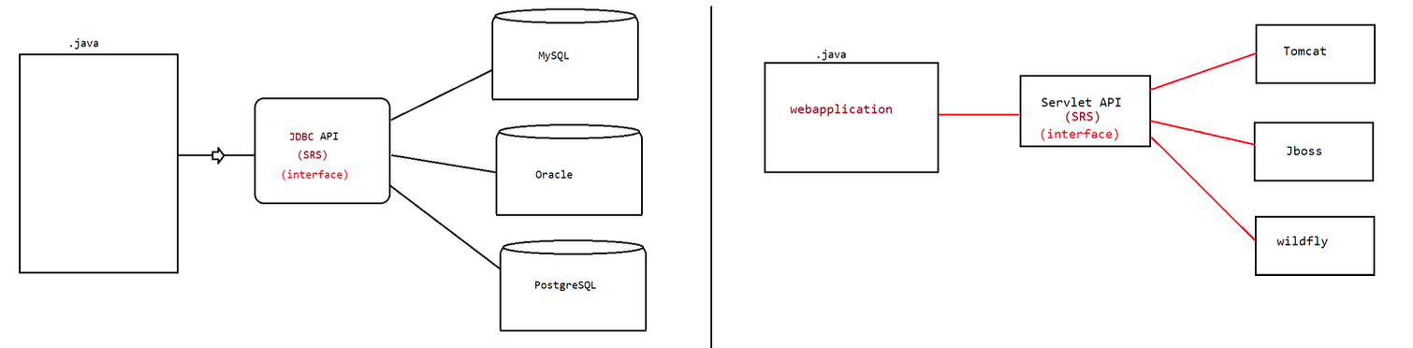
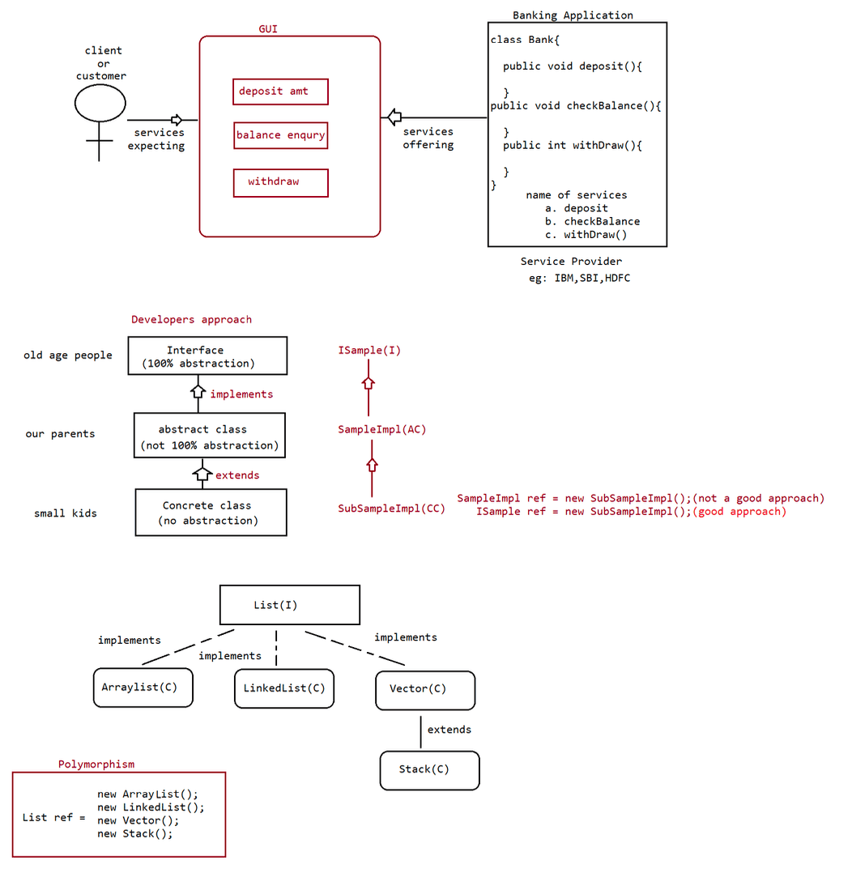

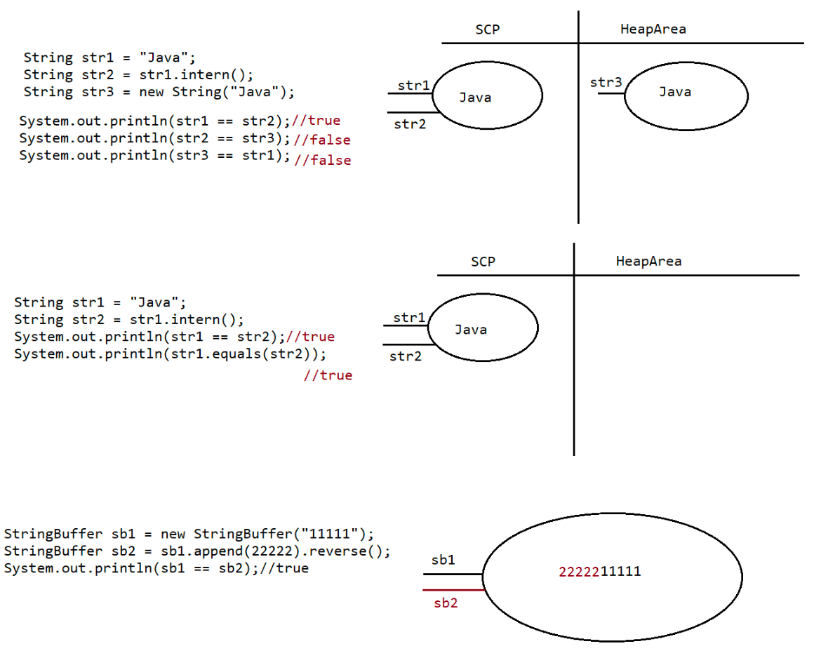

040 interface continuation
Difference b/w extends vs implements
case1:
extends :: One class can extends only class at a time
eg:: class One{}
class Two extends One{}
implements:: One class can implements any no of interface at a time.
eg:: interface One{
void methodOne();
}
interface Two{
void methodTwo();
}
class Demo implements One,Two{
public void methodOne(){}
public void methodTwo(){}
}
case2:
A class can extend a class and can implements any no of interfaces
simultaneously.
eg: interface One{
public void methodOne();
}
class Two{
public void methodTwo(){}
}
class Three extends Two implements One{
@Override
public void methodOne(){
....
}
@Override
public void methodTwo(){
..
}
}
case3:
An interface can extend any no of interfaces at at time.
eg:: interface One{
public void methodOne();
}
interface Two{
public void methodTwo();
}
interface Three extends One,Two{
public void methodOne();
public void methodTwo();
public void methodThree();
}
Answer the following
==================
Which of the following is true?
a. A class can extend any no of class at a time.b. An interface can extend only one interface at at time.
c. A class can implement only one interface at at a time.
d. A class can extend a class and can implement an interface but not both
simultaneously.
e. An interface can implements any no of Interfaces at a time.
f. None of the above
answer: f
Consider the expression X extends Y which of the possiblity of X and Y expression
is true?
1. Both x and y should be classes.
2. Both x and y should be interfaces.
3. Both x and y can be classes or can be interfaces.
4. No restriction.
Equation : X extends Y == > true
class extends class => true
interface extends interface => true
Answer: 3
Q>
Predict X,Y,Z
a. X extends Y,Z?
b. X extends Y implements Z?
c. X implements Y,Z?
d. X implements Y extends Z?
a. X extends Y,Z?
X => interface
Y => interface
Z => interface
b. X extends Y implements Z?
X => class
Y => class
Z => interface
c. X implements Y,Z?
X => class
Y => interface
Z => interface
d. X implements Y extends Z
combination is illegal
Interface Methods
=================
Every method present inside the interface is public.
Every method present inside the inteface is abstract.
How many declaration are valid?
a. void methodOne();
b. public void methodOne();
c. abstract void methodOne();
d. public abstract void methodOne();
answer: All are valid
public => To make the method available for every implementation class.abstract => Implementation class is responsible for providing the implementation.
eg: jdbc api (java.sql.*)
|
|
implementation should be given by
a. mysql
b. oracle
c. postgresql
Since the methods present inside the interface is
=> public,abstract methods illegal combination of modifiers are
static,private,protected,strictfp,synchronized,native,final.
Interface variables
===================
=> Inside the interface we can define variables.
=> Inside the interface variables define requirement level constants.
=> Every variable present inside the interface is by default public static final.
eg:: interface ISample{
int x=10;
}
public :: To make it available for implementation class Object.
static :: To access it without using implementation class Name.
final :: Implementation class can access the value without any
modification.
variable declaration inside interface
a. int x=10;
b. public int x=10;
c. static int x=10;
d. final int x=10;
e. public static int x=10;
f. public final int x=10;
g. static final int x=10;
h. public static final int x=10;
Answer: All are legal
since the variable defined in interface is public static final,we cannot use
modifiers like private,protected,transient,volatile.
since the variable is static and final,compulsorily it should be initialized at the
time of declaration otherwise it would result in
compile time error.
eg:: interace IRemote{ int x;}// compile time error.
=> interface variables can be accessed from implementation class,but cannot modify
if we try to modify
it would result in compile time error.
eg:: interface Remote{
int VOLUME = 100;
}
class Lg implements Remote{
public static void main(String... args){
VOLUME=0;//CE:: cannot assign a value to final variable VOLUMESystem.out.println("value of volume is ::"+VOLUME);
}
}
eg:: interface Remote{
int VOLUME = 100;
}
class Lg implements Remote{
public static void main(String... args){
int VOLUME=0;//local variable
System.out.println("value of volume is ::"+VOLUME);//0
}
}
Interface Naming Conflicts
==========================
Case 1::
If 2 interfaces contain a method with same signature and same return type in
the implementation class only
one method implementation is enough.
eg::
interface Left{ public void methodOne();}
interface Right{public void methodOne();}
class Test implements Left,Right{
@Override
public void methodOne(){
...
}
}
Case2:
If 2 interfaces contain a method with same name but different arguments in the
implementation class we have to provide
implementation for both methods and these methods acts as a Overload methods.
eg::
interface Left{ public void methodOne();}
interface Right{public void methodOne(int i);}
class Test implements Left,Right{
@Override
public void methodOne(){
...
}
@Override
public void methodOne(int i){
...
}
}
case3::
If two interfaces contains a method with same signature but different return
types then it is not possible to implement
both interface simultaneously.
eg:: interface Left { public void methodOne(); }
interface Right{ public int methodOne(); }
class Test implements Left,Right{@Override
public void methodOne(){
...
}
@Override
public int methodOne(){
...
}
}
Note:
Q> Can a java class implements 2 interfaces simultaneously?
yes possible, except if two interfaces contains a method with same signature
but different return types.
Variable naming conflicts::
Two variables can contain a variable with same name and there may be a chance
variable naming
conflicts but we can resolve variable naming conflicts by using interface names.
example1:
interface Left{ int x=888;}
interface Right{ int x=999;}
public class Test implements Left,Right{
public static void main(String... args){
System.out.println(Left.x);
System.out.println(Right.x);
}
}
Note:
inside interface the methods are by default "public and abstract".
inside interface the variables are by default " public static and final".
We can also write an interface without any variable or abstract methods.
interface Serializable{
}
class SampleImpl implements Serializable{
}
interface Cloneable{
}
class SampleImple implements Cloneable{
}
MarkerInterface
================
=> If an interface does not contain any methods and by implementing that
interface if our Object will get some ability such
type of interface are called "Marker Interface"/"Tag Interface"/"Ability
Interface".
=> example
Serializable,Cloneable,SingleThreadModel.example1
By implementing Serializable interface we can send that object across the
network and we can save state of an
object into the file.
example2
By implementing SingleThreadModel interfaace servlet can process only one client
request at a time so that we can
get "Thread Safety".
example3
By implementing Cloneable Interface our object is in a position to provide
exactly duplicate cloned object.
Without having any methods in marker interface how objects will get ability?
Ans.JVM is responsible to provide requried ability.
Why JVM is providing the required ability to Marker Interfaces?
Ans. To reduce the complexity of the programming.
Can we create our own marker interface?
Yes, it is possible but we need to customize JVM.(hard for beginner)
===================================================================================
===========
Adapter class(It is a design pattern allowed to solve the problem of direct
implementation of interface methods)
===================================================================================
===========
It is a simple java class that implements an interface only with empty
implememtation for every method.
If we implement an interface compulsorily we should give the body for all the
methods whether it
is required or not. This approach increases the length of the code and reduces
readability.
eg:: interface X{
void m1();
void m2();
void m3();
void m4();
void m5();
}
class Test implements X{
public void m3(){
System.out.println("I am from m3()");
}
public void m2(){}
public void m3(){}
public void m4(){}
public void m5(){}
}
In the above approach, even though we want only m3(), still we need to give body
for all the abstract methods, which increase the
length of the code, to reduce this we need to use "Adapater class".
Instead of implementing the interface directly we opt for "Adapter class".
Adapter class are such classes which implements the interface and gives dummyimplementation for all the abstract methods of interface.
So if we extends Adapter classes then we can easily give body only for those
methods which are interested in giving the body.
eg::
interface X{
void m1();
void m2();
void m3();
void m4();
void m5();
}
abstract class AdapaterX implements X{
public void m1(){}
public void m2(){}
public void m3(){}
public void m4(){}
public void m5(){}
}
class TestApp extends AdapterX{
public void m3(){
System.out.println("I am from m3()");
}
}
eg:
Servlet(I)
| implements
GenericServlet(abstract class)
| extends
HttpServlet(abstract class)
| extends
MyServlet(class)

Q>
String s1 = "null"+null+1;
System.out.println(s1);//nullnull1
Q>.
String s1 = 1+null+"null";
System.out.println(s1);//CE
Q>
String str = "sachin ramesh tendulkar";
System.out.println(str.indexOf('a') + str.indexOf("dulkar"));//18
Q> String name = null;
System.out.println(name.toUpperCase());//NPE
Q>
String[] strings = {"Java", "JEE", "Hibernate", "Spring", "SpringBoot"};
String languages = String.join("_", strings);
System.out.println(languages);// Java _JEE _ Hibernate _Spring _SpringBoot
Q>
String string = "JAVA";
StringBuffer sbuffer = new StringBuffer(string);
StringBuilder sBuilder = new StringBuilder(string);
System.out.println(string.equals(sbuffer));//false
System.out.println(string.equals(sBuilder));//false
System.out.println(sbuffer.equals(sBuilder));//false
Q>
public class Test{
Boolean b[] = new Boolean[2];
public static void main(String... args){
Test t= new Test();
System.out.println(t.b[0] + ":" +t.b[1]);
}
}
A. NullpointerException
B. false:false
C. true:true
D. null:null
E. RunTimeException other than NullPointerException
Answer: D
Q>
public static void main(String[] args) {
String str = "null";
if (str == null) {
System.out.println("null");
} else (str.length() == 0) {
System.out.println("zero");
} else {
System.out.println("some");
}
}
What is the result?
A. nullB. zero
C. some
D. Compilation fails.
E. An exception is thrown at runtime.
Answer: D
Given
1. public class KungFu {
2. public static void main(String[] args) {
3. Integer x = 400;
4. Integer y = x;
5. x++;
6. StringBuilder sb1 = new StringBuilder("123");
7. StringBuilder sb2 = sb1;
8. sb1.append("5");
9. System.out.println((x == y) + " " + (sb1 == sb2));
10. }
11.}
What is the result?
A. true true
B. false true
C. true false
D. false false
E. Compilation fails.
F. An exception is thrown at runtime.
Answer: B
Wrapper classes and String class are immutable(changes will be made not in the same
copy but in different copy)
StringBuilder and StringBuffer are mutable(changes will be made on the same object)

